# **Create and Integrate SAP Build Process Automation (SBPA) Workflows with SAP Business Technology Platform (BTP) ABAP Environment.**

Beginners

3.5 hrs.

[BTP ABAP Environment, Tutorial, Beginners, SBPA Workflows](https://developers.sap.com/tutorial-navigator.html?tag=tutorial%3Aexperience%2Fintermediate&tag=tutorial%3Atype%2Ftutorial&tag=programming-tool%3Aabap-exte), [SAP Build Process Automation](https://developers.sap.com/tutorial-navigator.html?tag=software-product%3Atechnology-platform%2Fsap-build%2Fsap-build-process-automation)

As part of this mission, you will build an application on BTP ABAP Environment using ABAP RESTful Application Programming Model and integrate with SAP Build Process Automation to run the business process workflows with intuitive low-code and no-code capabilities.

You will learn how BTP ABAP environment and SBPA together can help you build the apps you need at the speed your business demands.

**Scenario:**

Basic Travel Application will be created in **SAP BTP ABAP Environment**. On Creating a Travel entry, a **workflow** **will trigger in SAP Build Process Automation** and the status of the Travel entry will be set to “Awaiting Approval”.

This workflow process in SAP Build Process Automation will create a task in the approver’s Inbox, which can be accessed from “**My Inbox**” Application integrated in SAP Build Process Automation.

Once the Approver actions the task i.e. (**Accepts/ Rejects**) a callback will be made to SAP BTP ABAP Environment notifying the Outcome of workflow completion.

BTP ABAP Environment will use the Notification to further **set the status of Travel** to Accepted/ Rejected in the Travel Application.

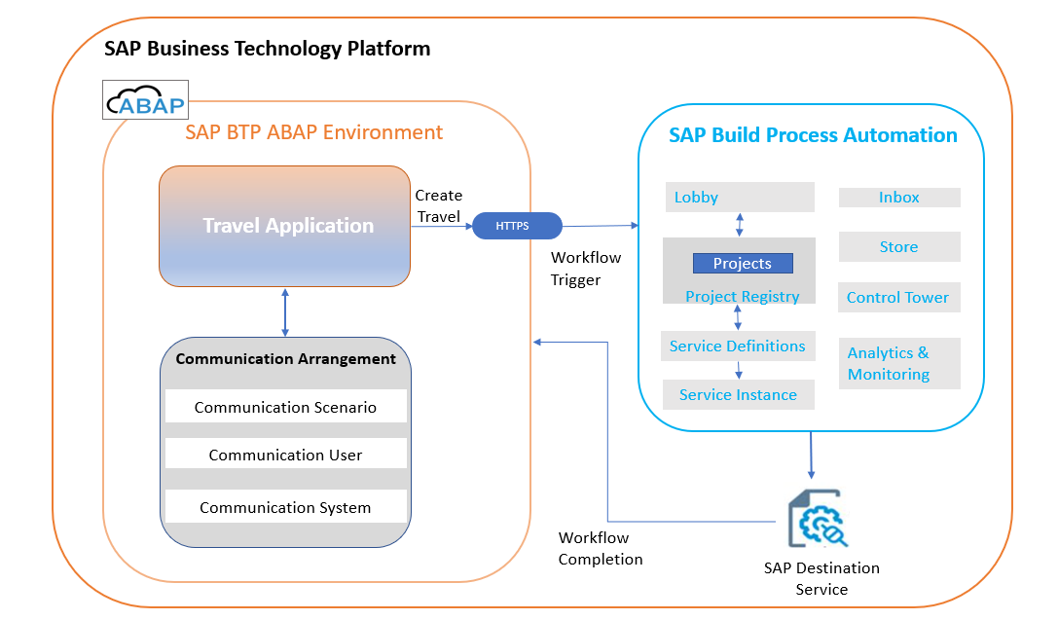

# **Group 1**

## **Integration of BTP ABAP Environment with SAP Build Process Automation**

1 Tutorial Time 15mins [ABAP Extensibility](https://developers.sap.com/tutorial-navigator.html?tag=programming-tool%3Aabap-extensibility), [ABAP Connectivity, ABAP Development](https://developers.sap.com/tutorial-navigator.html?tag=programming-tool%3Aabap-connectivity&tag=programming-tool%3Aabap-development)

Set up connection between BTP ABAP Environment and SAP Build Process Automation.

### **Tutorials**

* Integration of BTP ABAP environment (*Steampunk*) with SAP Build Process Automation.

## **Group 1: Tutorial 1**

## **Integration of BTP ABAP environment with SAP Build Process Automation.**

Beginner 15mins [ABAP Extensibility](https://developers.sap.com/tutorial-navigator.html?tag=programming-tool%3Aabap-extensibility), [ABAP Connectivity, ABAP Development](https://developers.sap.com/tutorial-navigator.html?tag=programming-tool%3Aabap-connectivity&tag=programming-tool%3Aabap-development)

Configure connection between BTP ABAP environment (*Steampunk*) and SAP Build Process Automation

You will learn:

* SBPA Integration with BTP ABAP Environment.
* Creation of a Communication Arrangement for SAP Build process Automation Workflows.
* Creation of callback destination from SAP Build Process Automation to Steampunk.
* Properties to be used in the callback destination to enable it for SBPA.
* Adding the callback destination in SAP Build Process Automation.

Owner: [Ruchi Dobriyal](https://github.com/RDobriyal)

Prerequisites:

* You have a **licensed version** of SAP BTP ABAP Environment
* SAP BTP ABAP Environment instance with the **Administrator role**
* [SAP BTP tenant with SAP Build Process Automation](https://developers.sap.com/tutorials/spa-subscribe-booster.html) **subscription. Instance and service key** must be created for SBPA. You can use the **Booster** for Subscription as described in the link:

<https://developers.sap.com/tutorials/spa-subscribe-booster.html>

### **Step 1: Overview**

To integrate BTP ABAP environment with External Systems or Services like **SAP Build Process Automation** you create a **Communication Arrangement**.

A Communication Arrangement describes which communication partners communicate with each other in the scenario, and how they communicate. Communication Arrangement is formed by combining the below artifacts.

* **Communication Scenario**: Communication Scenario is a design time description of how two communication partners communicate with each other. It consists of technical information like inbound and/or outbound services example OData or SOAP as well as supported authentication methods. There are various **standard communication scenarios** provided by SAP which are ready to use, like in this tutorial we would be using SAP\_COM\_0863.
* **Communication System**: The communication system represents the communication partner within a communication e.g., **SAP Build Process Automation** in this case.
* **Communication User**: Communication users are used by Communication Systems to authenticate themselves to be able to connect to your system in BTP ABAP Environment.

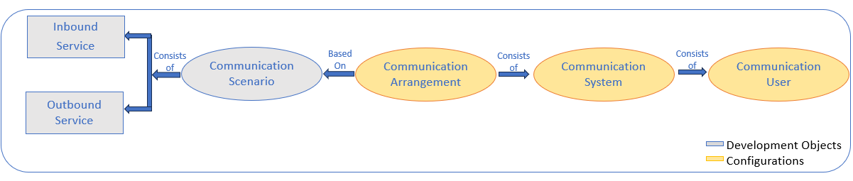

### **Step 2: Create Communication Arrangement.**

You will now create a communication arrangement in the **ABAP system** on BTP ABAP Environment using **service key of SBPA** Instance.

Note: Communication Arrangement is not transported between systems but created locally by the system administrator.

1. **Get** SAP Build Process Automation **Service Key**

* In the BTP Cockpit **navigate** to your development **subaccount.**

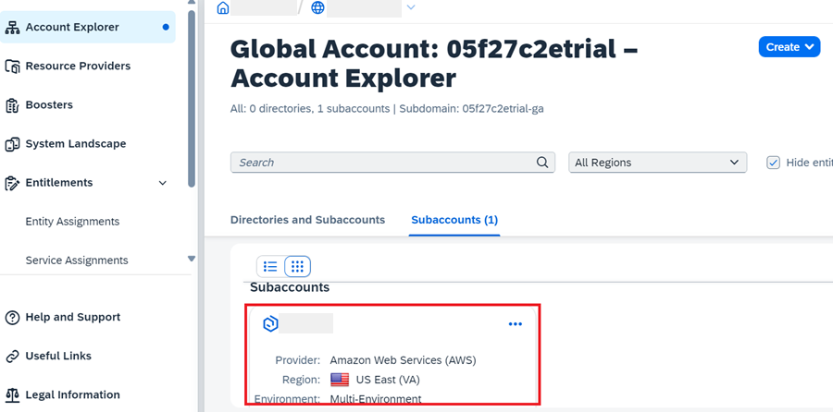

* Click on **Services and Instances**.

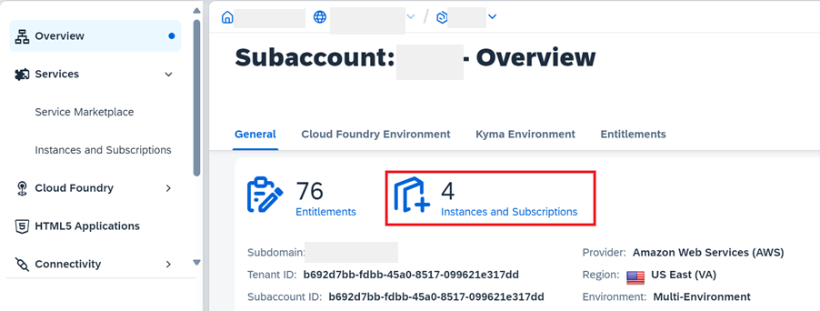

* Click on **Instances**.

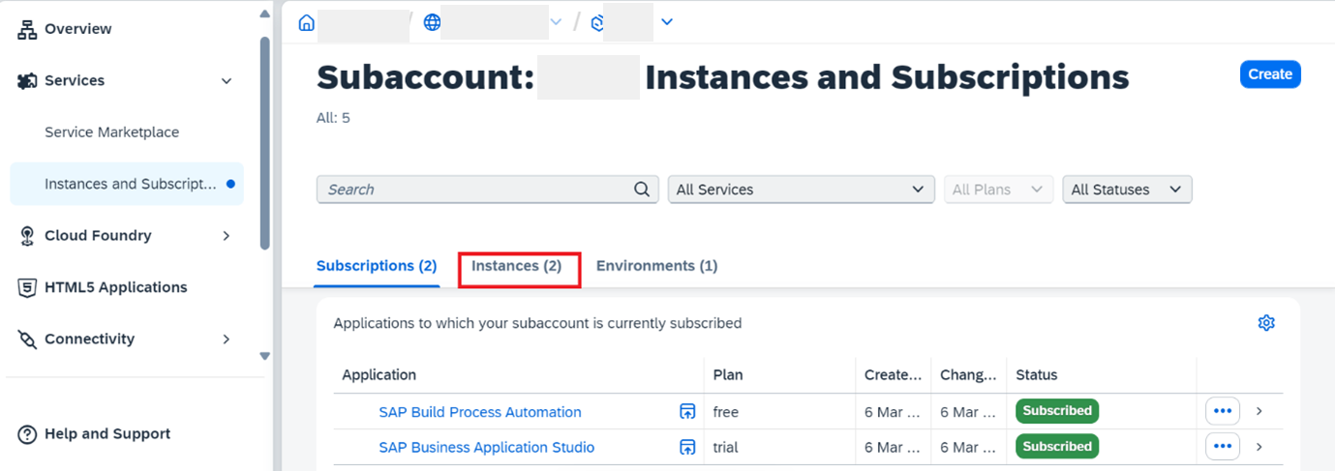

* Click the name of your **SAP Build Process Automation instance**.

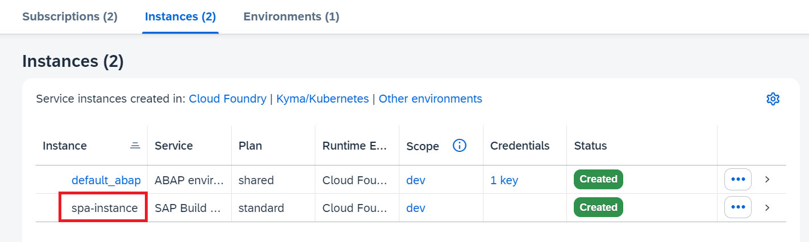

* From the **navigation pane**, choose **Service Keys**.

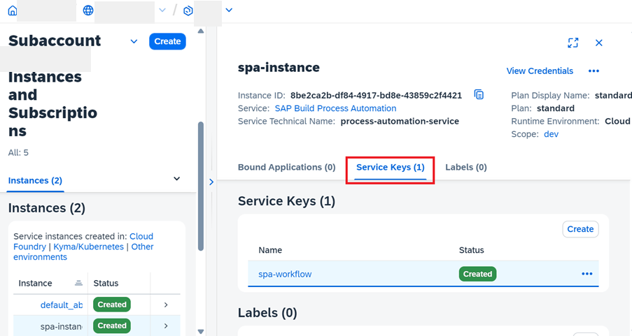

* Select one entry and **copy the service key**.

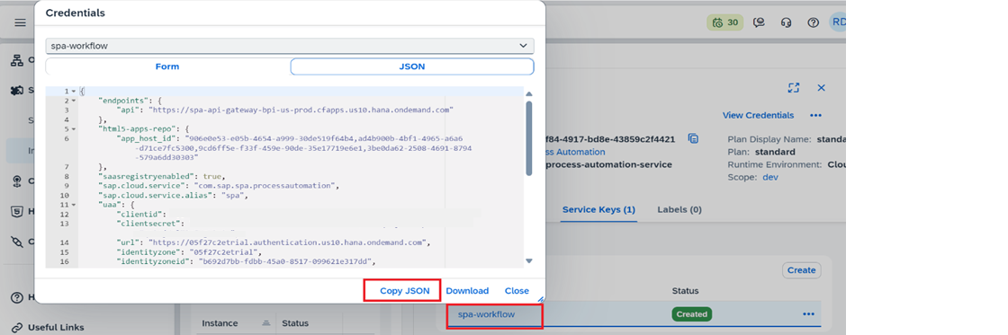

1. **Open** the Communication Arrangements app in your SAP BTP ABAP Environment.

* Click on the BTP ABAP environment instance in your BTP sub account to **navigate** to the **Fiori launchpad**.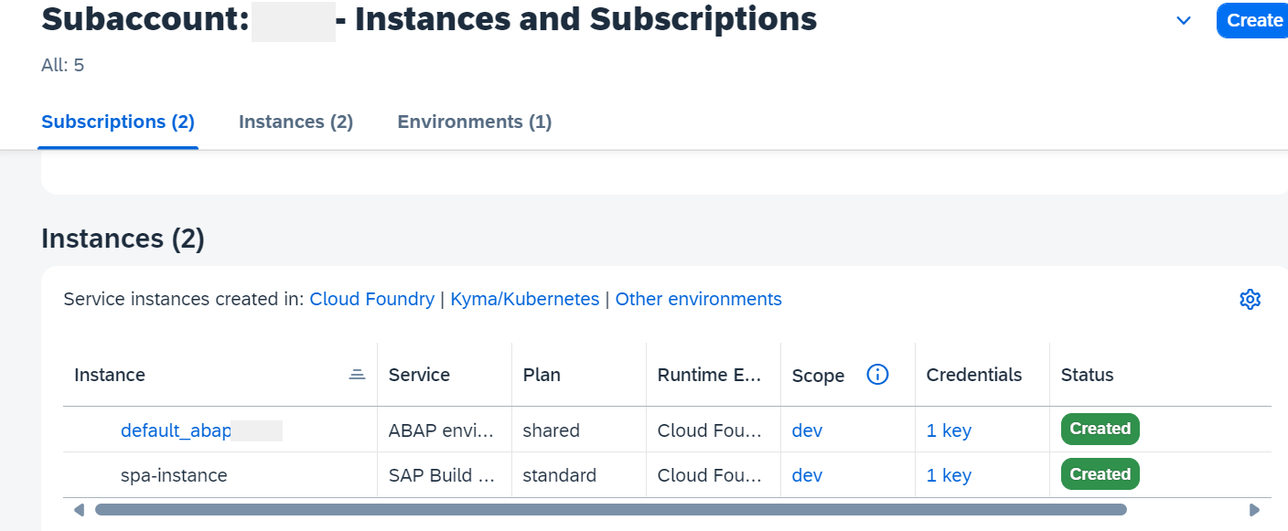
* In the Fiori launchpad **open communication Arrangement**.

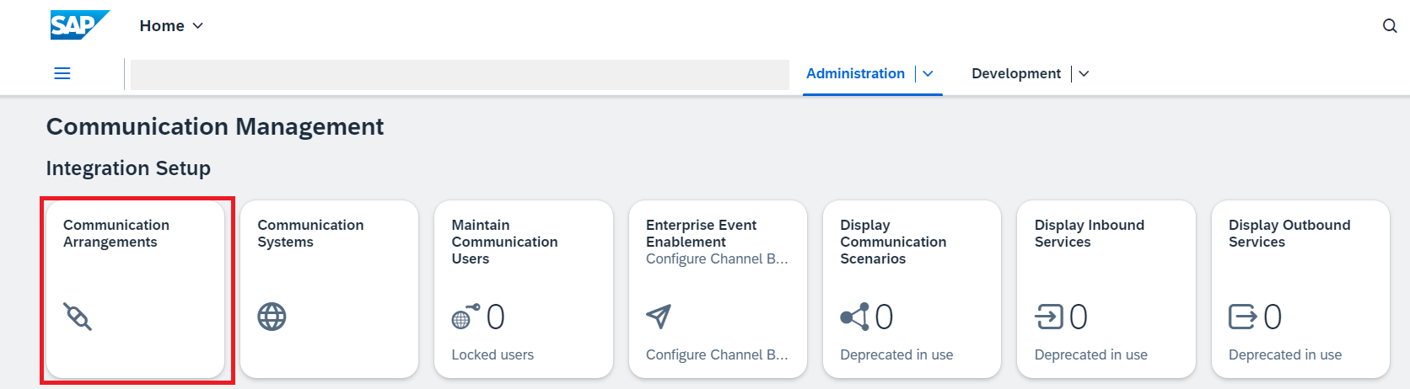

1. Click on **New** to create communication arrangement.

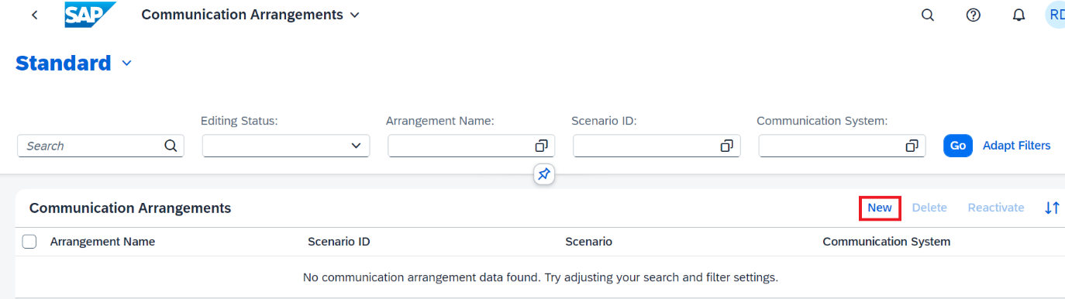

1. Communication Scenario **SAP\_COM\_0863**.

Communication Scenario SAP\_COM\_0863 is a **ready-to-use** communication scenario provided by SAP for integration with SAP Build Process Automation.

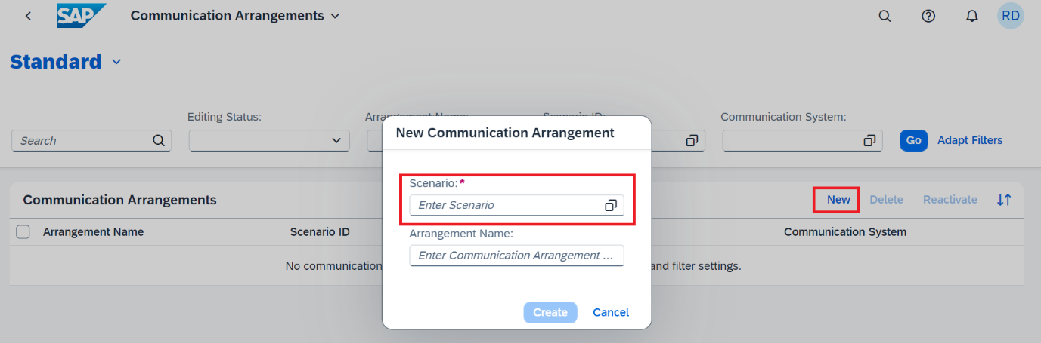

1. Set **Additional Properties**.

Once the scenario is selected pop-up window extends with prefilled Communication Arrangement name and option to **set additional properties**, enter, or create Communication User and to enter service key.

**Click on** Additional Properties, **set given value**, and click **Close.**

Consumer Type (Workflow) - DEFAULT

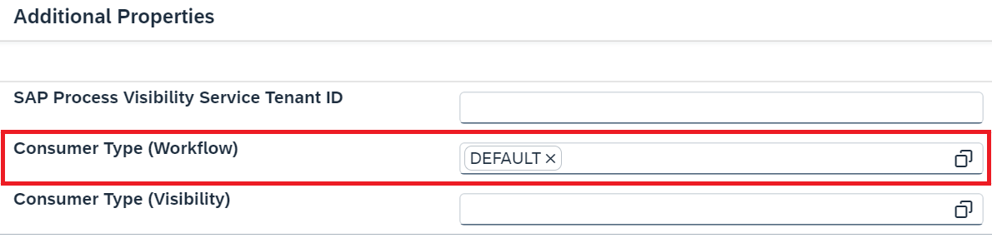

***Note:*** *The* ***consumer type*** *is used to identify the* ***default communication arrangement*** *i.e., if the SBPA Communication Arrangement has* ***Consumer Type (Workflow)*** *set to ‘****DEFAULT****’ then the system will try to trigger all* ***workflows in SBPA by default****. Therefore, default assignment can be done only on* ***one*** *Communication arrangement for a Consumer Type.*

1. Create a **New** Communication **User**.

Select a communication user (of which you know the password) or create a new one to use for **inbound communication** (from SBPA to your BTP ABAP environment).

* **Click** New to create a Communication User.

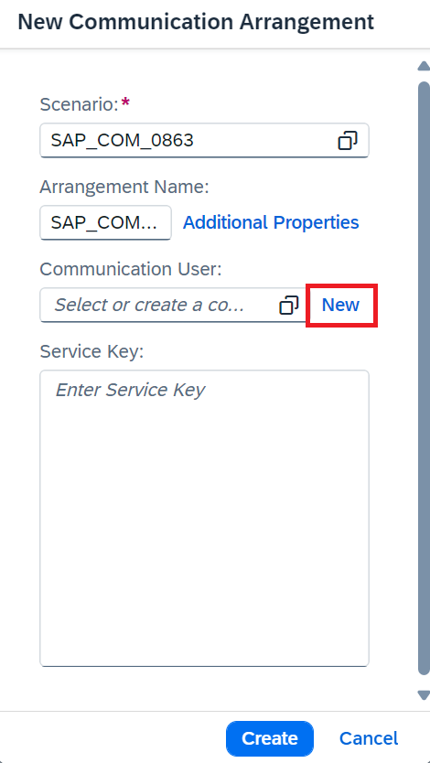

* Clicking on new navigates to the **Create Communication User** **App.**

Enter the below info and click on **Create.**

User Name: ZTEST\_USER\_SBPA

Description: SBPA User

Password: Click on **Propose Password** *(Save the password for later use)*

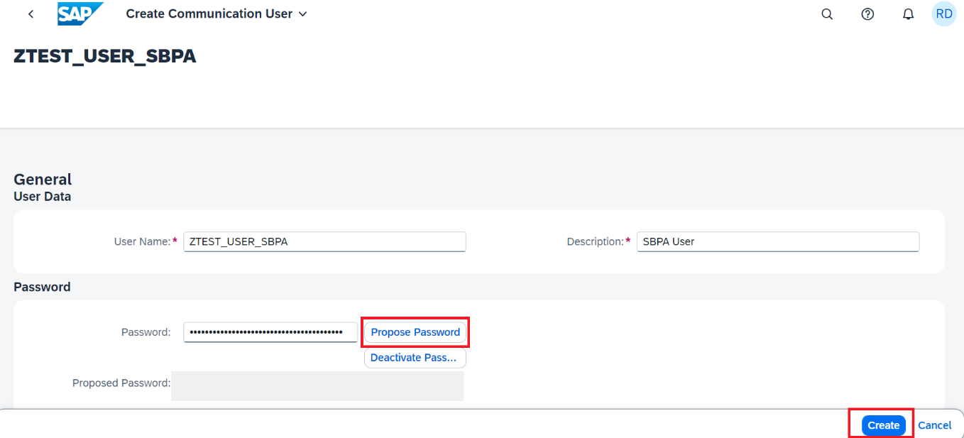

***Note****: Save the proposed* ***Password*** *and* ***Username*** *as that would be required during creation of* ***callback destination.***

1. In the field **Service key** paste the **SBPA instance service key** that we retrieved as part of ‘Get SAP Build Process Automation Service Key’ and click **Create**.

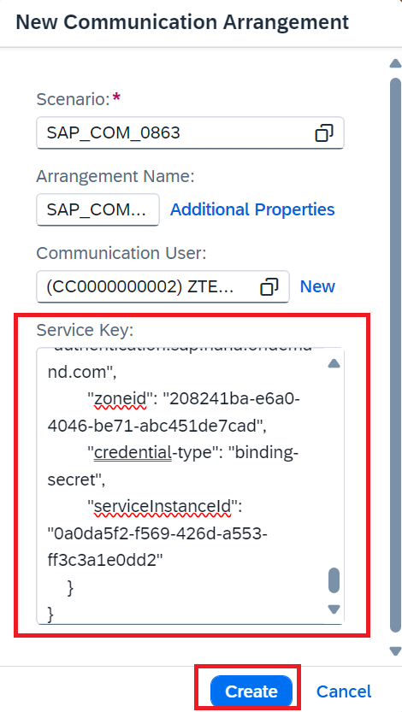

1. Communication Arrangement is **saved**.

*Note: Save the highlighted API-URL for later use while creating callback destination.*

-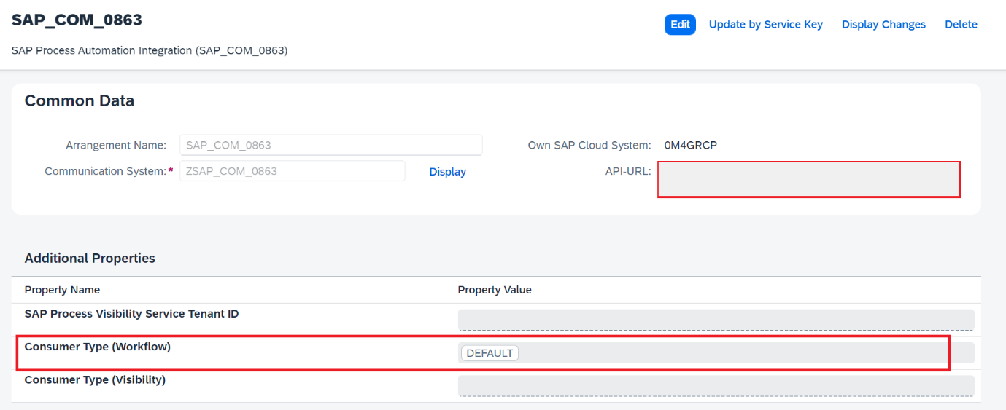

### **Step 3: Create Callback destination.**

**Create** a destination in the SAP BTP subaccount, to enable the **inbound communication** to the BTP ABAP environment. In addition, the destination **must be enabled** for use in SAP Build Process Automation.

The destination will be used for the **callback to the SAP BTP ABAP environment from SAP Build Process Automation**. The callback is triggered on the completion of workflow process on SAP Build Process Automation.

1. In the BTP Cockpit **navigate** to your development **subaccount**.



1. **Choose** Connectivity > Destination > Create Destination.

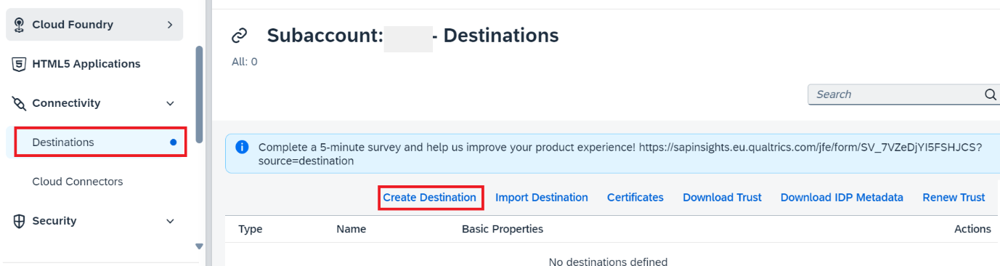

1. Choose **Blank Template** and enter the following data and click on **Save**.

***Name:*** abap-cloud-dev-steampunk-canary (Any Name)

**Type**: HTTP

**Description:** SBPA to ABAP Callback Destination

**URL**: Enter the API-URL saved during Communication Arrangement creation. If not saved access the communication arrangement and copy the API URL displayed under Common Data > API-URL.It is the APIURL for **BTP** ABAP Environment instance.

**Proxy Type**: Internet

**Authentication**: BasicAuthentication

**User:** Enter the Inbound Communication User created during Communication Arrangement creation.

**Password:** Enter the Password of the (inbound) communication user in the Communication Arrangement.

**Additional Properties**: Click on New Properties and add Additional Properties.

“sap.applicationdevelopment.actions.enabled” → true.

“sap.processautomation.enabled ” → true

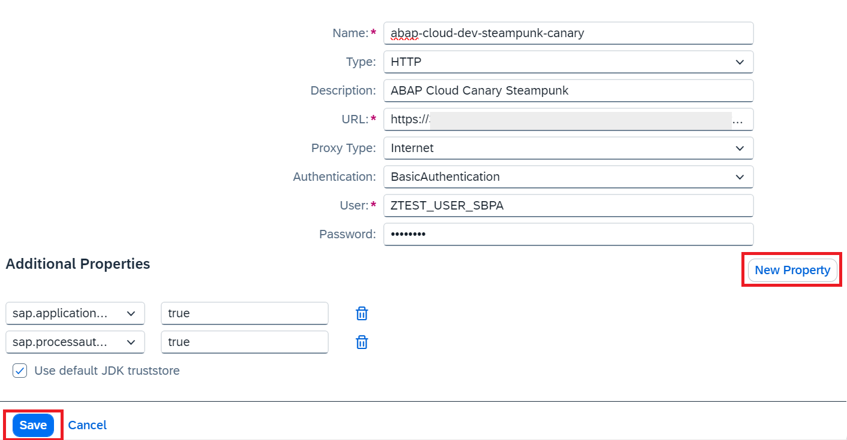

*The Addition of Additional Properties*  ***“sap.applicationdevelopment.actions.enabled”*** *and “****sap.processautomation.enabled*** *” enables the destination for use in SBPA.*

### **Step 4: Add Callback destination in SAP Build process Automation.**

1. **Open** the SAP Build Process automation from your subaccount.

Subaccount > Instances and Subscriptions > Subscriptions > SAP Build Process Automation

* **Click** on SAP Build Process Automation to **open** the Application. 

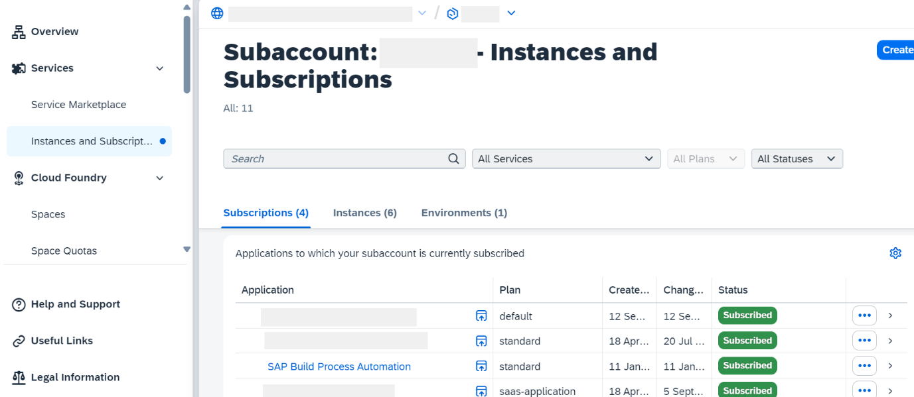

1. Navigate to **Control Tower > Destinations**.

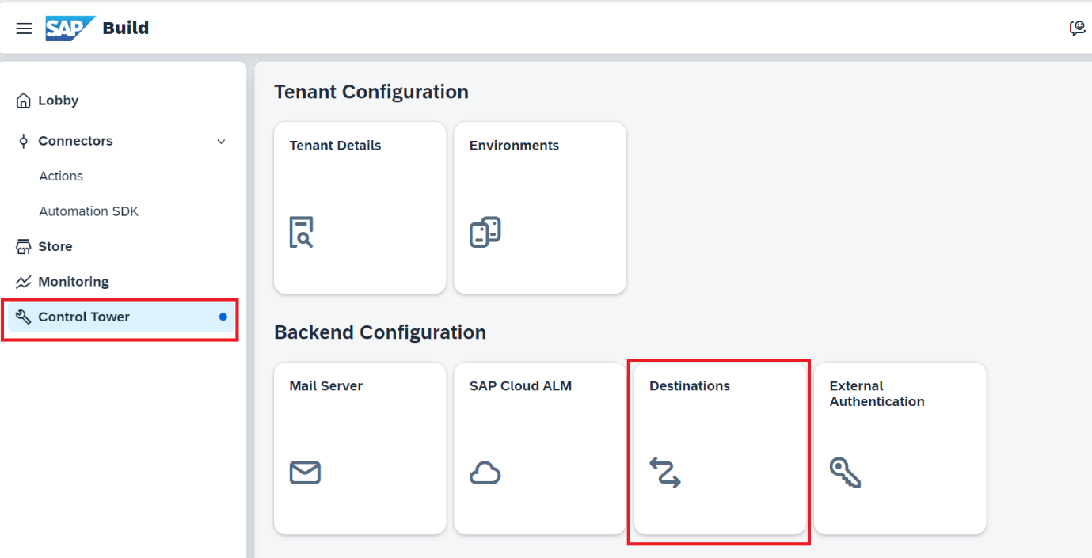

1. Choose **Destinations > New Destination**.

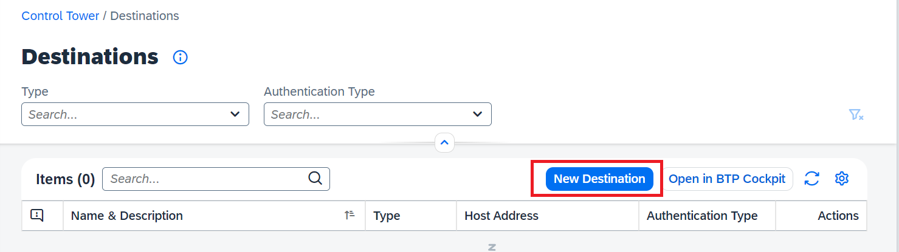

1. **Select** the destination that you have **created in SAP BTP cockpit** and click **Add**.

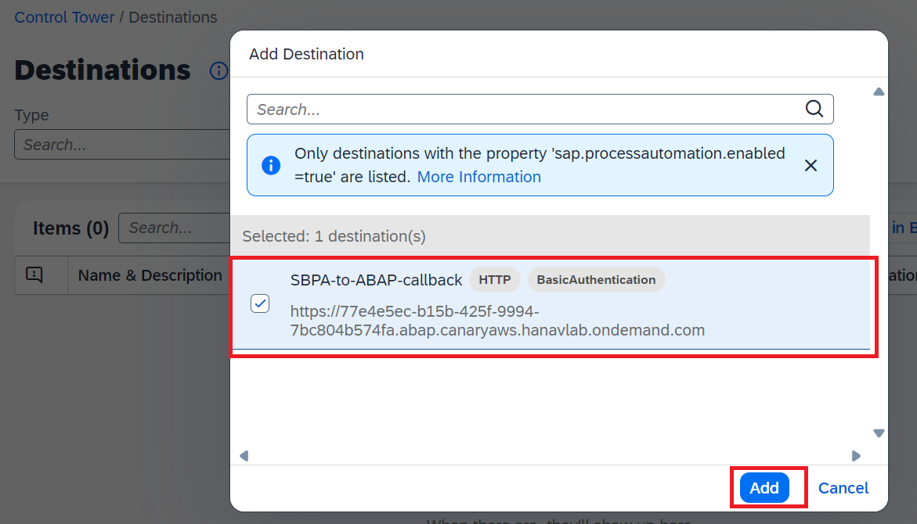

### **Step 5: Test Yourself.**

Which Communication Scenario do we use to create Communication Arrangement for Integration with SAP Build Process Automation.

* SAP\_COM\_0863
* SAP\_COM\_0542
* Both

# **Group 2**

## **Build your Business Process Workflow with SAP Build Process Automation**

4 Tutorial 1. 5 hr

[SAP Build Process Automation, Beginner, Mission](https://developers.sap.com/tutorial-navigator.html?tag=software-product%3Atechnology-platform%2Fsap-build%2Fsap-build-process-automation&tag=tutorial%3Aexperience%2Fbeginner&tag=tutorial%3Atype%2Fmission), [SAP Business Technology Platform](https://developers.sap.com/tutorial-navigator.html?tag=software-product:technology-platform/sap-business-technology-platform/sap-business-technology-platform)

Develop, deploy, and run the business process workflow with intuitive low-code and no-code capabilities.

### **Tutorials**

* Create a Business Process Workflow in SBPA
* Create a trigger.
* Create and configure approval form.
* Create and configure Action in the process flow.
* Release and Deploy

## **Group 2: Tutorial 1**

## **Create a Business Process Workflow in SBPA.**

Beginner 10mins

[SAP Build Process Automation, Beginner, Tutorial](https://developers.sap.com/tutorial-navigator.html?tag=software-product%3Atechnology-platform%2Fsap-build%2Fsap-build-process-automation&tag=tutorial%3Aexperience%2Fbeginner&tag=tutorial%3Atype%2Ftutorial), [SAP Business Technology Platform](https://developers.sap.com/tutorial-navigator.html?tag=software-product:technology-platform/sap-business-technology-platform/sap-business-technology-platform)

Create a Business Project and Process to build and extend business processes.

You will learn.

* How to create an SAP Build Process Automation project.
* How to create a process that automates travel approval.

Owner: [Ruchi Dobriyal](https://github.com/RDobriyal)

Prerequisites

* Access to a [SAP BTP tenant with SAP Build Process Automation](https://developers.sap.com/tutorials/spa-subscribe-booster.html" \t "_blank)

### **Step1. Create a Business Process Project**

1. In the **Lobby**, choose **Create.**

*The lobby is a central page for creating, accessing, and managing your projects in SAP Build. You can access business application processes, company configured templates, and other resources for your end-to-end business process.*

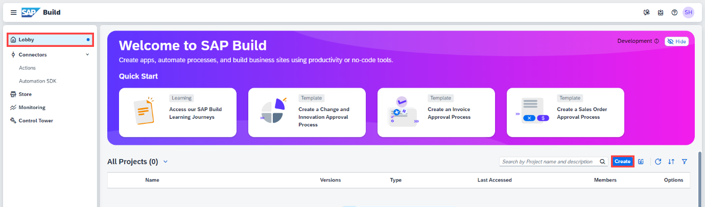

2. Build an **Automated Process**.

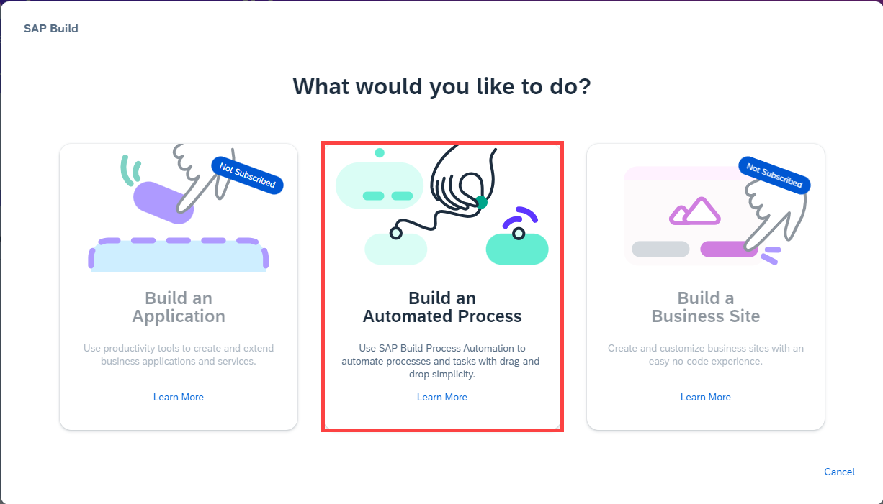

3. Select **Business Process.**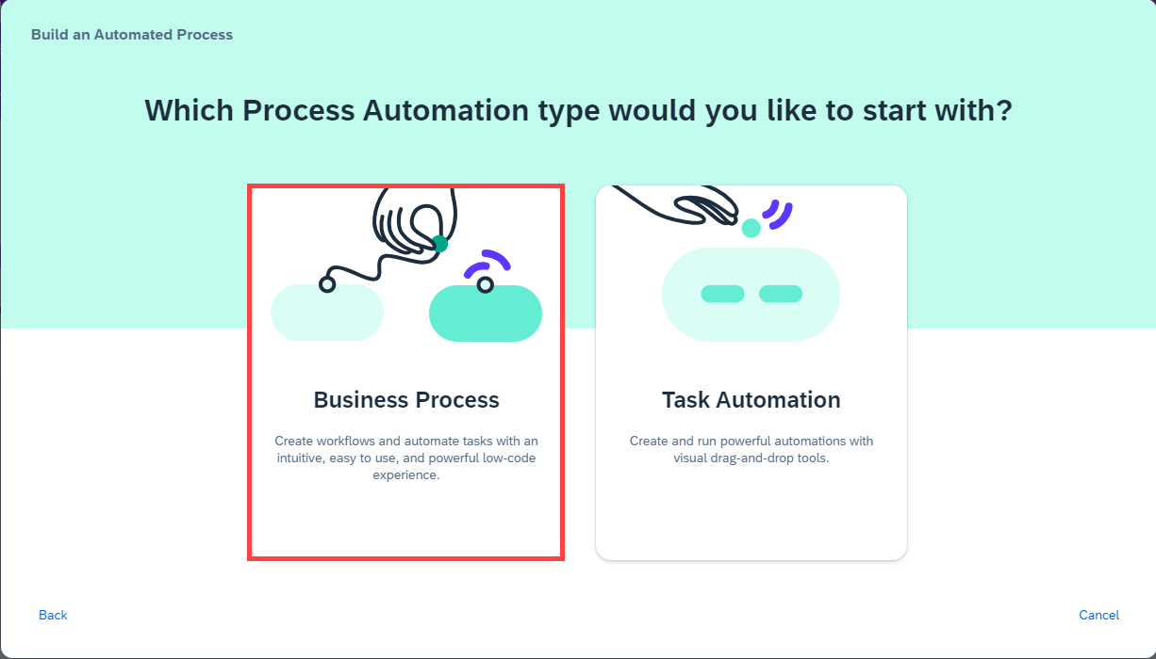

*Business Process Projects are a collection of skills in SAP Build Process Automation. Projects are part of the internal business processes of a company and are defined based on business scenarios. A project can contain a set of processes, forms, automations, and decisions, which are reusable artifacts.*

4. In the **Create a Business Process Project dialog box**, do the following:

* Enter a **Project Name**: RAP110\_Travel\_Workflow
* Enter a **Short Description**: RAP 110 Travel Workflow
* Choose **Create**

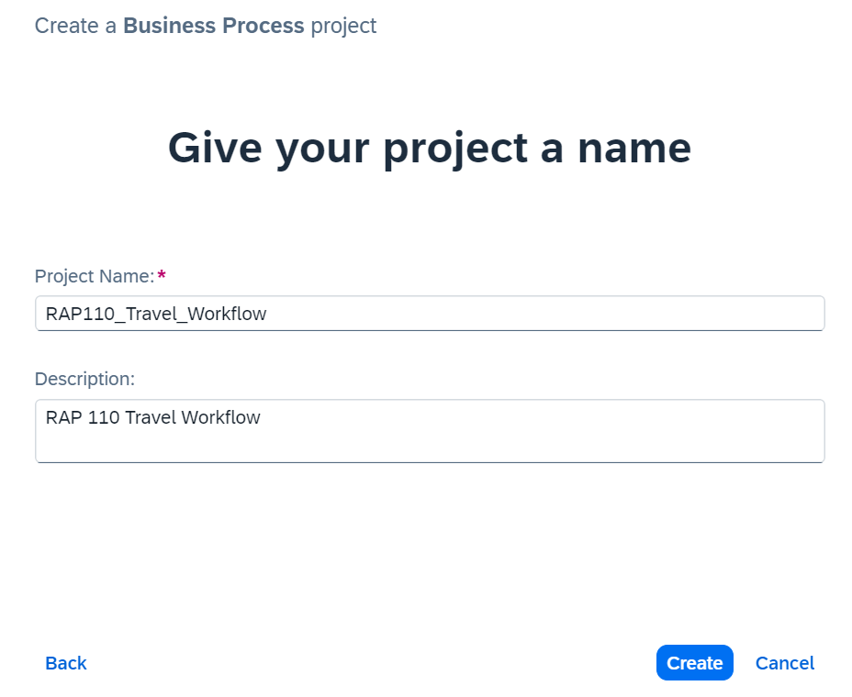

### **Step 2: Create a business process.**

1. A new tab opens with the newly created project.
2. In the Create Process dialog box, provide the following:

* Enter a **Name**: Travel Approval Processing
* Enter a **Description** for your process: Process to handle Travel Workflow
* Choose **Create**

*Inside a project, you can create a process. This* ***process is equivalent to a workflow*** *in any business scenario. As part of the process flow, you could create various artifacts such as* ***forms, decisions, automations.***

**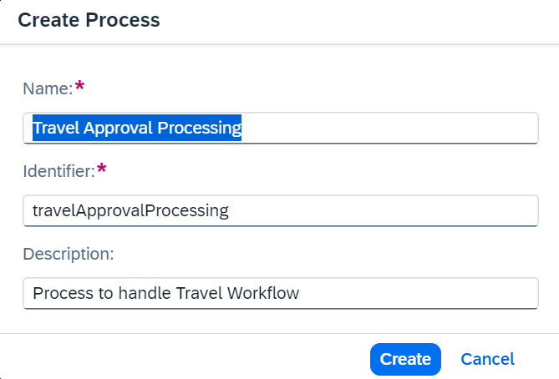**

*Note that the* ***Identifier****field is auto filled.*

### **Step 3: Test Yourself.**

Inside a process you can Create a project.

* True
* False

## **Group 2: Tutorial 2**

## **Create a Process Trigger.**

Beginner 15mins

[SAP Build Process Automation, Beginner, Tutorial](https://developers.sap.com/tutorial-navigator.html?tag=software-product%3Atechnology-platform%2Fsap-build%2Fsap-build-process-automation&tag=tutorial%3Aexperience%2Fbeginner&tag=tutorial%3Atype%2Ftutorial), [SAP Business Technology Platform](https://developers.sap.com/tutorial-navigator.html?tag=software-product:technology-platform/sap-business-technology-platform/sap-business-technology-platform)

Create an API trigger for the business process to be called from external system.

You will learn.

* How to create an API trigger to start an instance of a business process from any service, like SAP Build Apps

Prerequisite:

* Complete Group 2, Tutorial1.

Owner: [Ruchi Dobriyal](https://github.com/RDobriyal)

A business process is started by defining a **trigger**, an event that indicates to your SAP Build Process Automation tenant to **start a process instance**.

Process triggers can be a form, such as a request form, an API call, where an external system starts the process or an Event. You may also start the instance with an event trigger which on-boards and listens to back-end events emitted from an external source system and reacts to such events by triggering artifacts such as processes and automations.

***As part of this tutorial, we will start an instance of the process using an API call, with the inputs for the call configured from the process builder. These inputs will then be used as input fields in your process.***

### **Step 1: Create the data type for the API Trigger.**

A **data type** is an artifact describing a **data structure** that can be used as an **input** and/or an **output parameter** in automations or processes. You have two options to create the fields in data type. You can either import an excel file or define the fields manually.

As part of this tutorial, we would be creating data type defining each field with field name and type of field manually.

1. Go to your project and click on **Create > Data Type.**

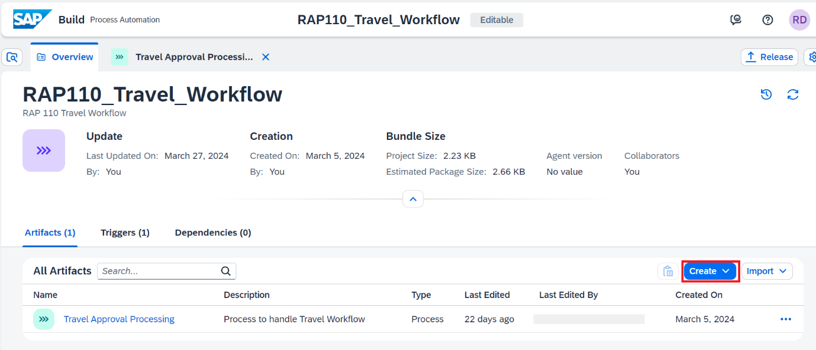

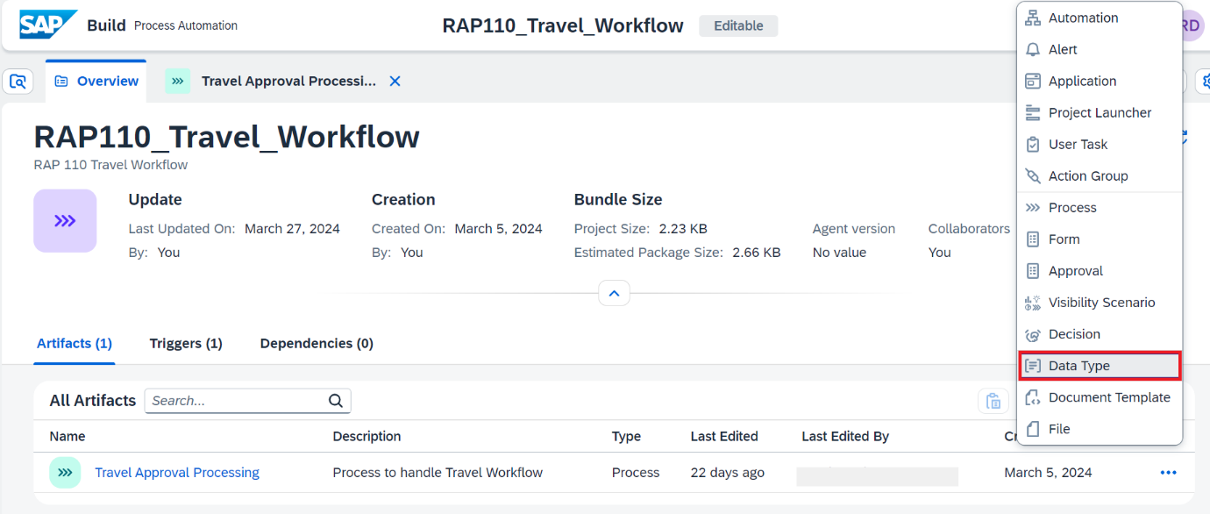

1. Name the data type **Travel Context** and click on **Create**.

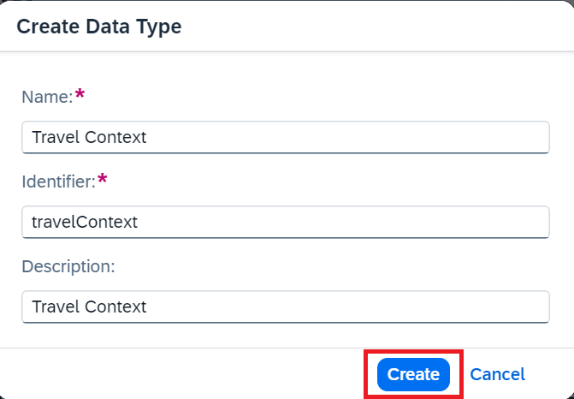

1. Click on **New Field** to add new fields to the data type **Travel Context**.

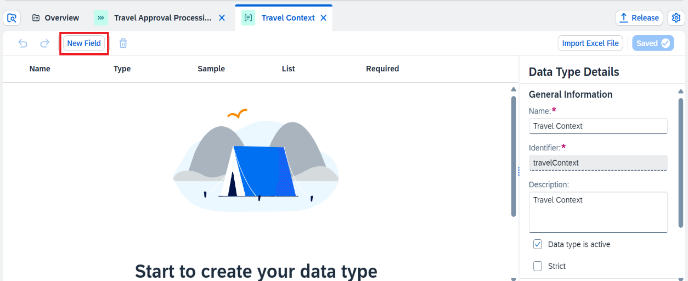

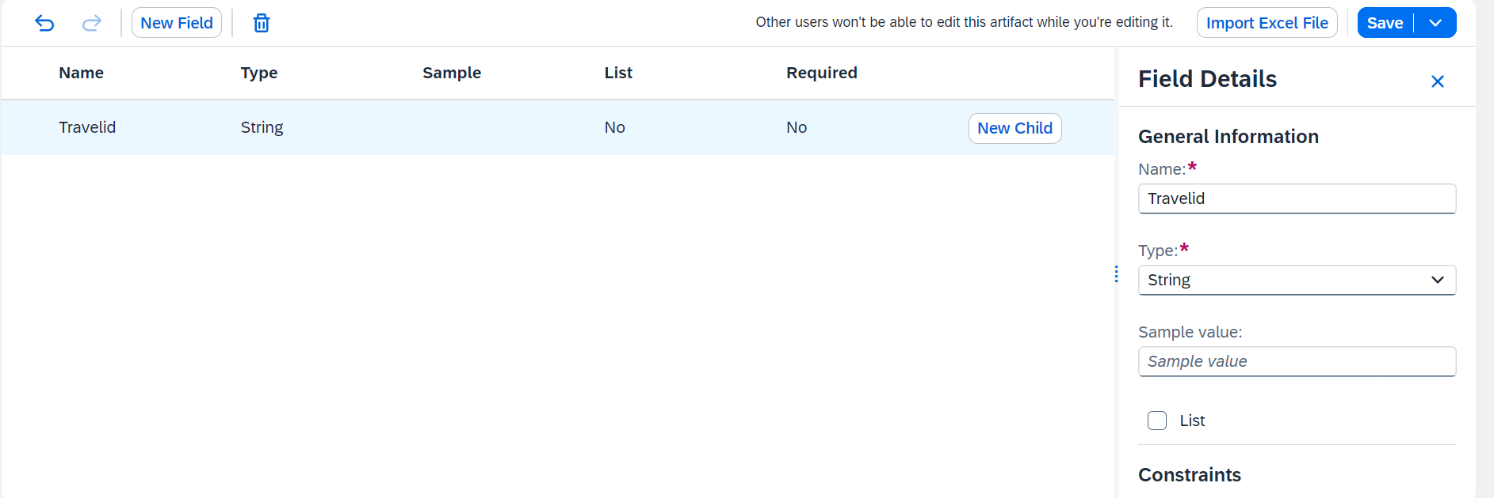

1. **Repeat** the process to add all the fields of the type as shown below.

|  |  |
| --- | --- |
| **Field Name** | **Type** |
| Travelid | String |
| AgencyName | String |
| BookingFee | String |
| CurrencyCode | String |
| CustomerName | String |
| TotalPrice | String |

***Note:****The spelling and casing of the fields, as well as any extra spaces, is crucial because the API to trigger the process will require the fields exactly as written.*

*For the tutorial we are keeping a format as first letter of all words in the field name capital and without underscore.*

Your final data type looks as below. Click **Save** to save the data type.

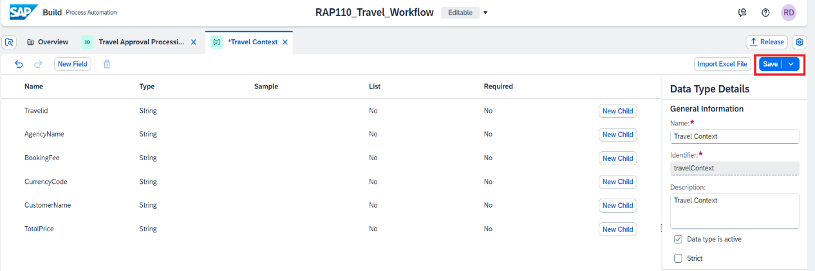

### **Step 2: Create an API Trigger for the process.**

1. **Open** process Travel Approval Processing.

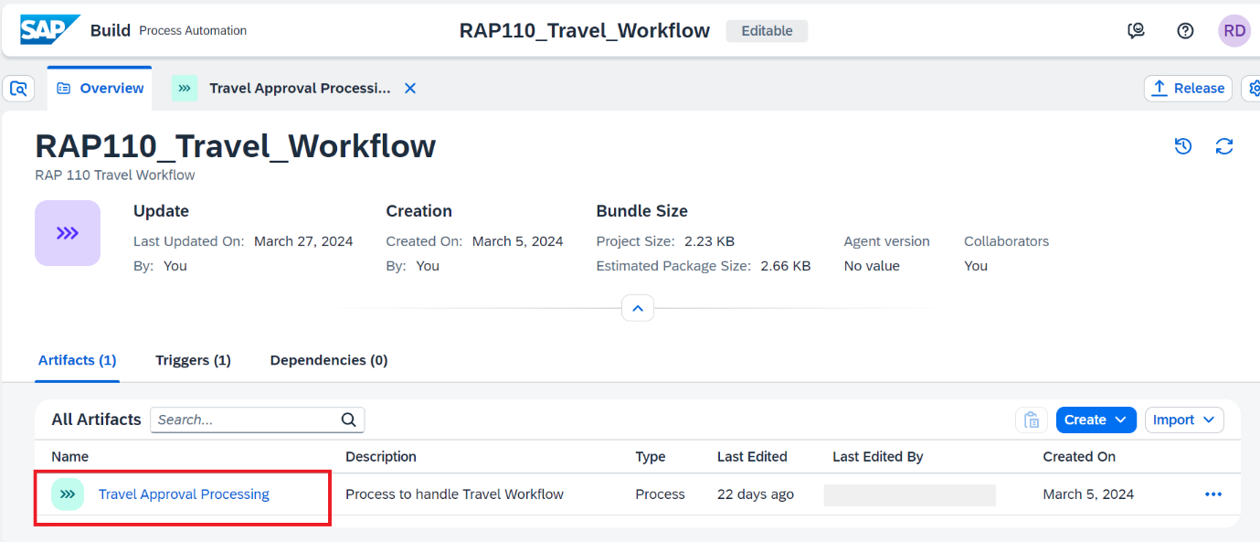

1. To add an API trigger for the process, click on **Add API trigger**.

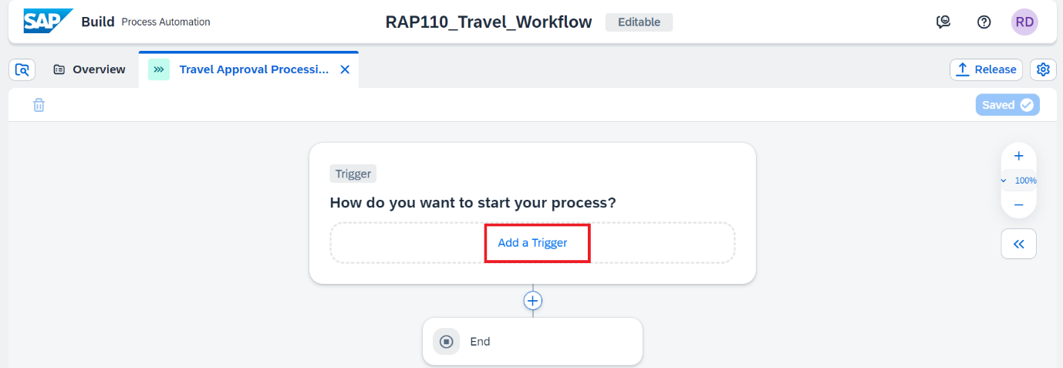

1. Choose **Call an API** as we are creating an API based trigger so that we can **trigger the process from external system** like S/4HANA or BTP ABAP Environment.

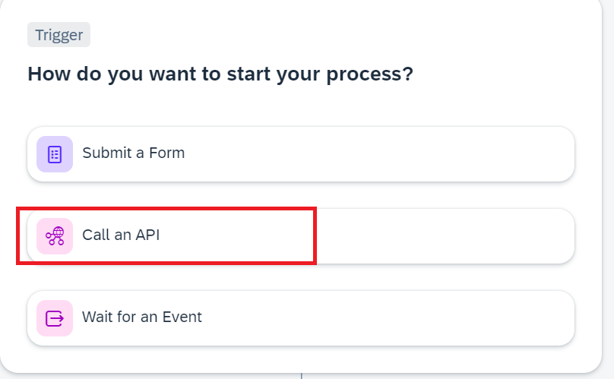

1. **Enter** the below details for the trigger. Choose Create.

**Name**: Travel Approval Trigger

**Description**: Travel Approval Trigger

*Please note that the identifier will be filled by itself.*

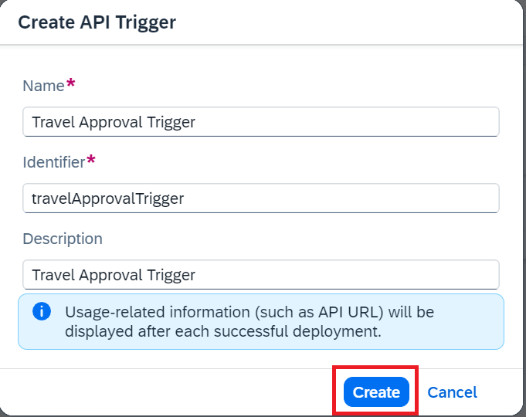

### **Step 3: Create input for the process.**

1. Open the Process Details by clicking on the Canvas.

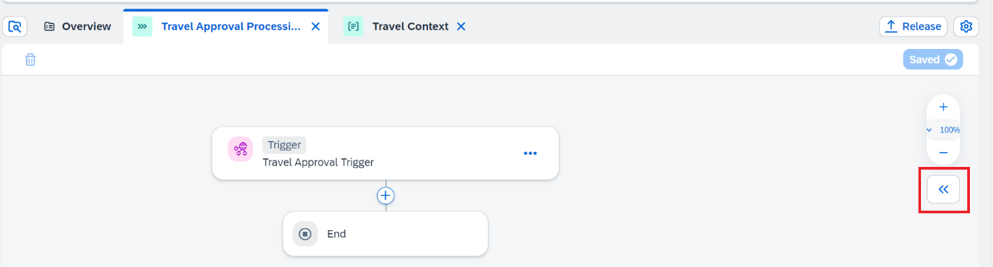

1. Choose **Variables.** Then choose **Configure** to configure process inputs.

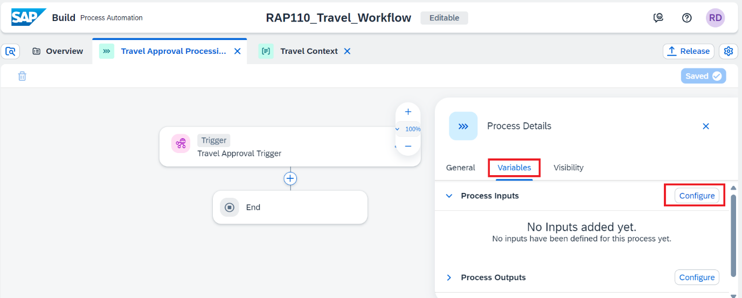

1. In the Configure Process Inputs window, choose **Add Input** to add parameters.

Add the following parameter and click on **Apply.**

|  |  |  |
| --- | --- | --- |
| **Name** | **Identifier** | **Type** |
| Travel Context | TravelContext | Select the data type you created in Step 1  Travel Context |

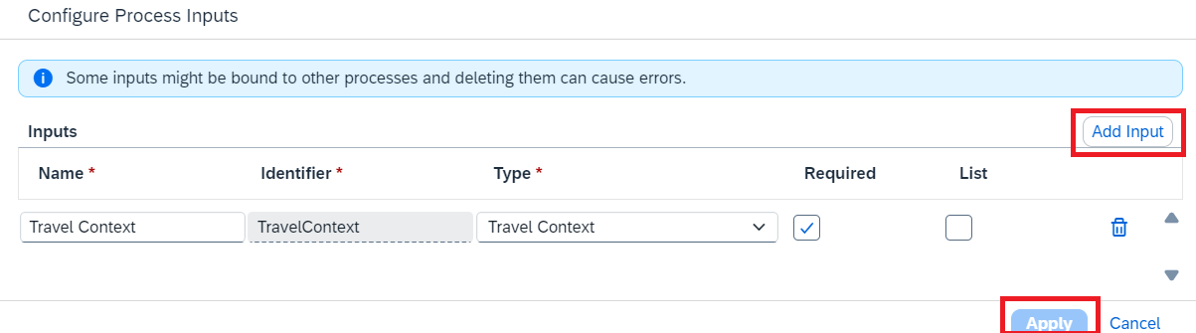

Process Input Fields are now visible in the Process Details.

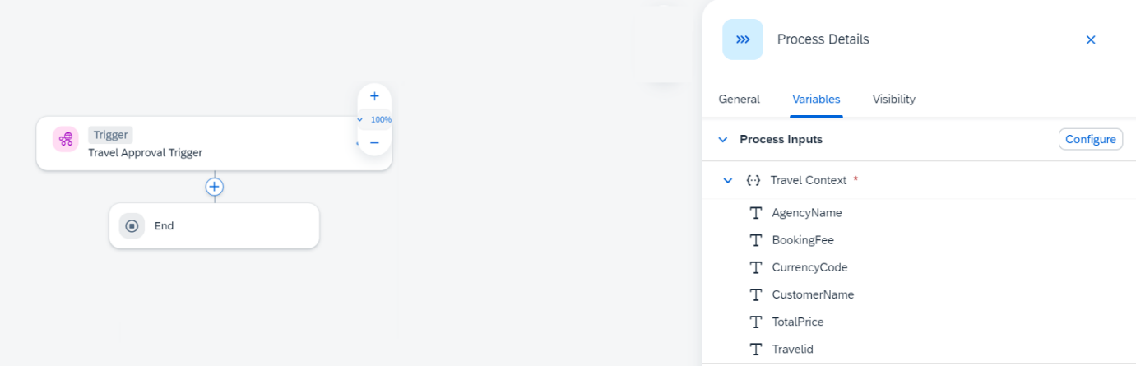

1. Save the project.
2. Once the trigger is created successfully, you can view the trigger under the **Triggers** section in the **Overview** page.

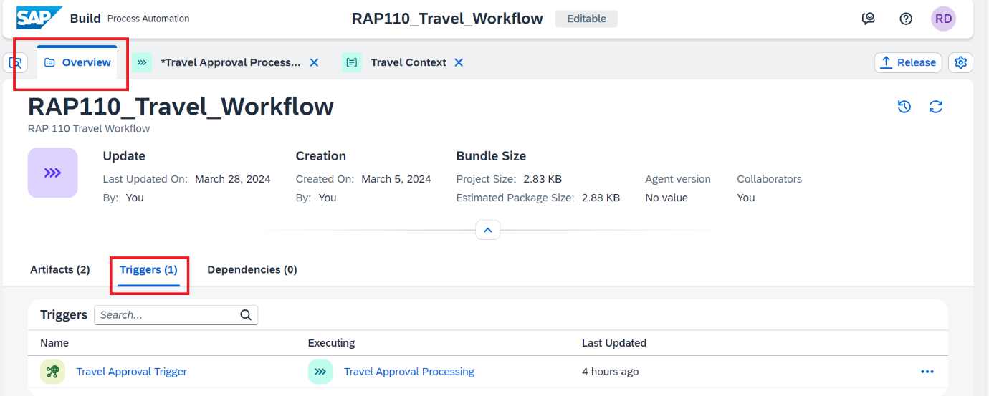

*You can edit, deactivate, or delete the API trigger properties from Triggers tab in the respective process builder overview.*

*Deactivate means that while the trigger exists in design-time, you cannot consume it in runtime.*

*Delete will permanently delete the trigger from design-time, but for already deployed processes the trigger will still exist at runtime.*

*In general, any changes in the trigger will be effective only when the process is released and deployed.*

*Note: All the API triggers that are created in that project will be shown.*

### **Step 4: Test Yourself.**

What Kind of Triggers can be used to trigger workflow process from BTP ABAP Environment.

* Form Trigger.
* Event Trigger
* API Trigger

## **Group 2: Tutorial 3**

## **Create and Configure Approval Form.**

Beginner 15mins

[SAP Build Process Automation, Beginner, Tutorial](https://developers.sap.com/tutorial-navigator.html?tag=software-product%3Atechnology-platform%2Fsap-build%2Fsap-build-process-automation&tag=tutorial%3Aexperience%2Fbeginner&tag=tutorial%3Atype%2Ftutorial), [SAP Business Technology Platform](https://developers.sap.com/tutorial-navigator.html?tag=software-product:technology-platform/sap-business-technology-platform/sap-business-technology-platform)

Create approval form to send tasks for approvals to business users.

You will learn.

* How to design the form with layout and input fields using drag-and-drop approach
* How to configure the forms as a process steps.

Prerequisite:

* Complete Group 2, Tutorial1 and 2.

Owner: [Ruchi Dobriyal](https://github.com/RDobriyal)

Tasks are a part of any business process. SAP Build Process Automation helps you to create forms that are made available to the business users in their inboxes to take relevant action.

These interactive forms can be created by dragging and dropping the text elements and input fields into the canvas. Once a form has been created, it can then be used as an approval step in the business process.

Let us now explore how to create an Approval Form.

### **Step 1: Create an Approval Form**

The approval form will be used to get faster and easier approvals from the business users, to take informed decisions, and get rid of sending emails. These approval forms could be about approving or rejecting sales orders, invoices, onboarding, IT requests, etc. The forms are then converted into tasks in an automated workflow which will appear in approver’s inbox and can be accessed using “**My Inbox”** integrated **with SAP Build Process Automation.**

You can create these different forms using the **Form Builder** embedded in the process builder using different form field options. You can design and modify them without any coding.

1. Go to process **Travel Approval Processing** and choose + below the Trigger.

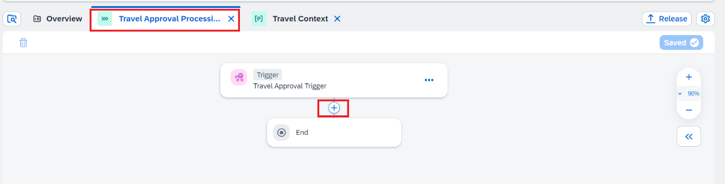

1. Choose **Approval** from the available options.

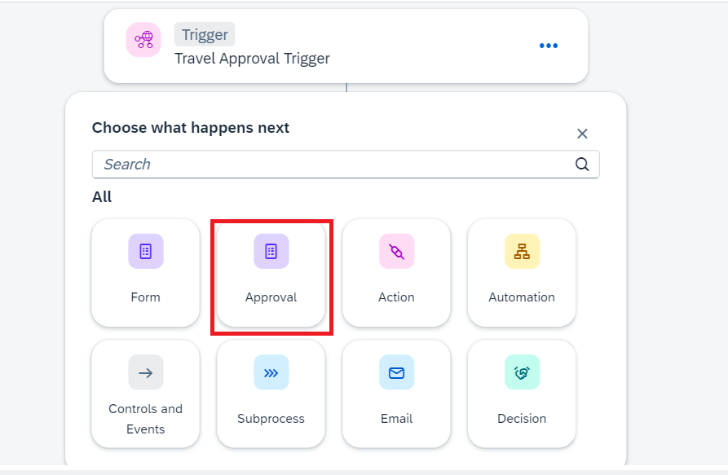

1. Choose **Blank Approval**.

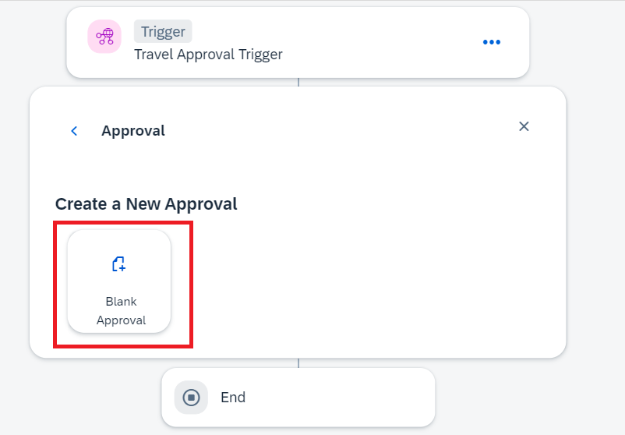

1. In the **Create Approval** dialog box, do the following:

* In the Name field enter: **Approval Form**
* In the Description field enter: **Form to approve or reject Travel.**
* Choose **Create**

**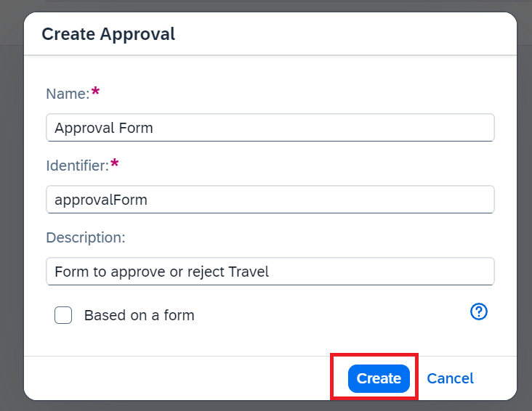**

1. Choose **Open Editor** of the Approval Form.

Two ways to open editor are marked in the below screen shot.

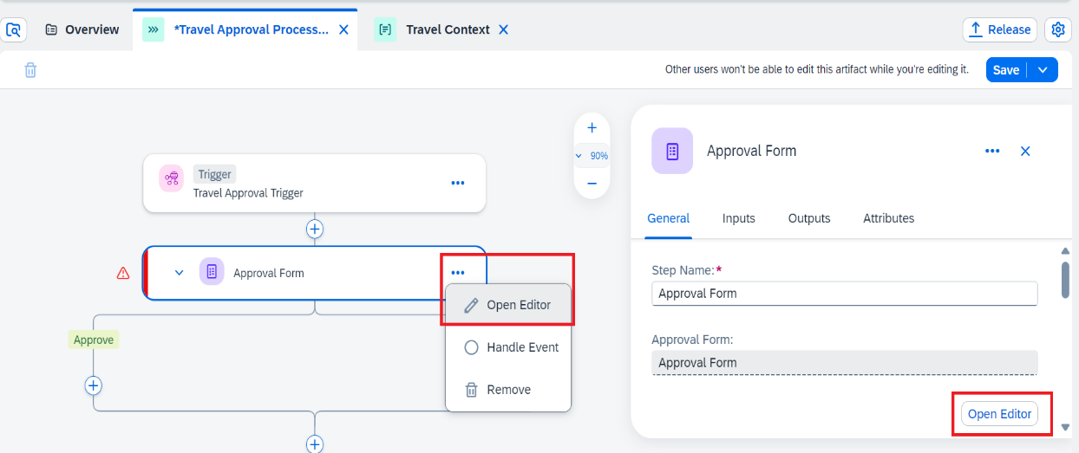

1. Design the Approval Form in the form builder by dragging-and-dropping fields into the form editor and configuring respective field settings.

| **Form Fields** | **Field Settings with Label** |
| --- | --- |
| Headline 1 | Travel Approval |
| Paragraph | A new travel request has been received. Please review and confirm whether it can be fulfilled or not. |
| Paragraph | Travel Details: |

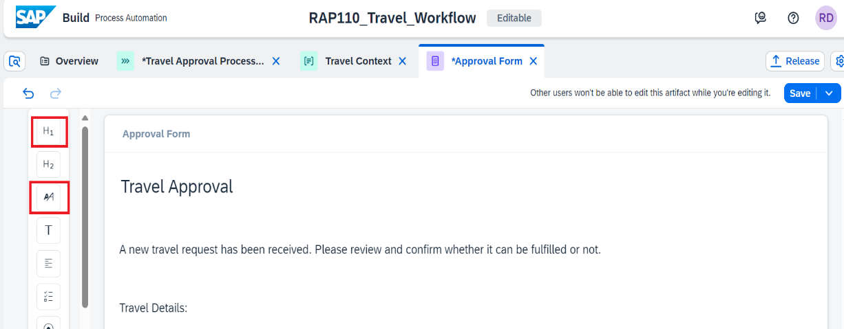

1. Add **Input Fields**, enter the labels and select the **Read Only** checkbox.

These fields will take value from the input of the process i.e., fields sent from the external system.

| **Form Fields** | **Field Settings with Label** |
| --- | --- |
| Text | Travel ID |
| Text | Agency Name |
| Text | Booking Fee |
| Text | Currency Code |
| Text | Customer Name |
| Text | Total Price |

Drag and drop the text boxes to create the fields:

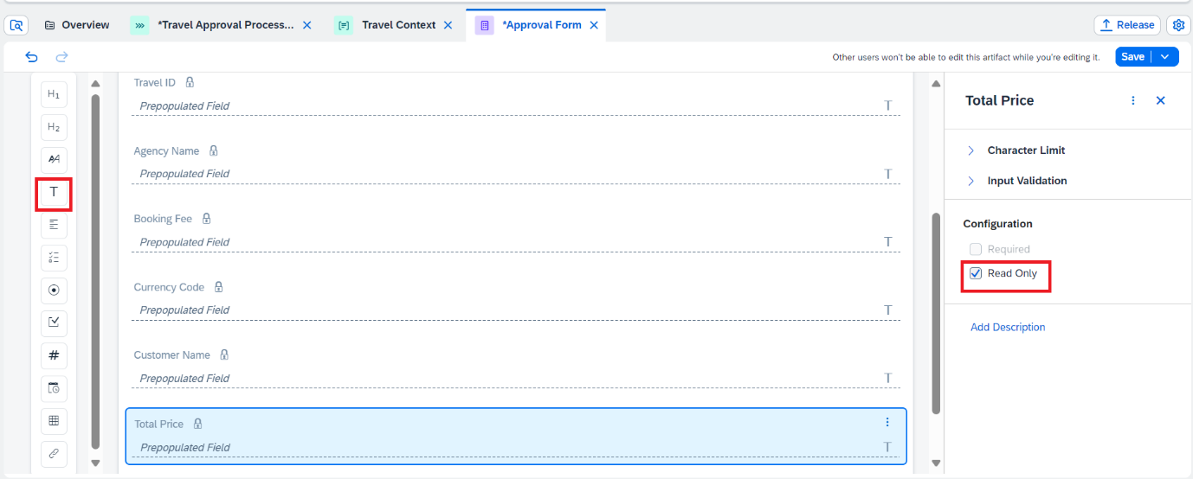

1. Add **Input Fields** and enter **only** the labels. These will be fields which approver can fill while evaluating the approval form. They can be made Required depending upon the scenario.

| **Form Fields** | **Field Settings with Label** |
| --- | --- |
| Text | Comment |
| Required | Set Required |

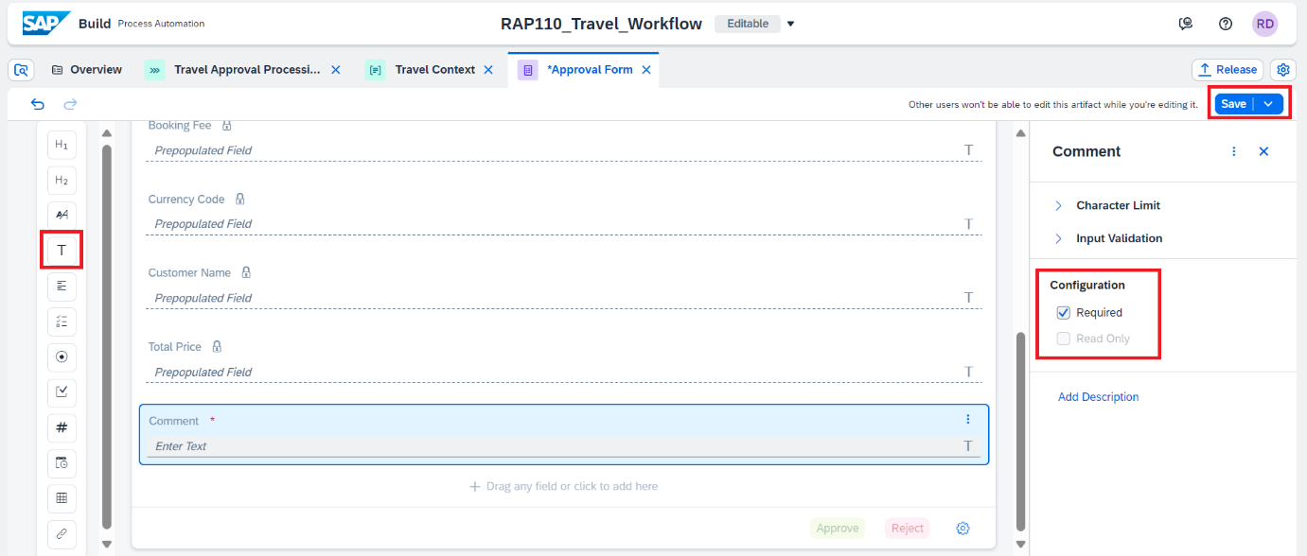

1. **Save** the Form.

### **Step 2: Configure the Approval Form in the Process Flow.**

Once the approval form is created its time to include it in the process flow and configure it to take the read only field values from Process Input.

1. Go to process **Travel Approval Processing** and choose + below the Trigger.



1. Choose **Approval** from the available options.



1. Select the approval form you created.

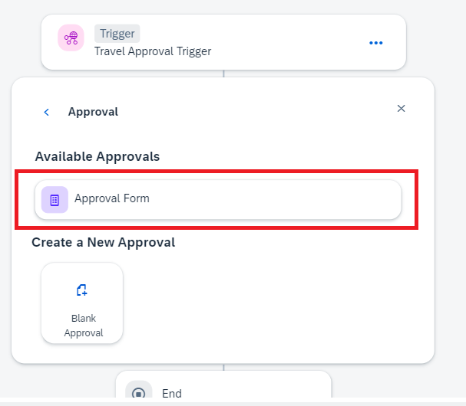

1. Select the **Approval Form** to configure the **General** information section.
2. Set the **title** of the task that will be displayed in the **Inbox**, enter the below details.

| **Fields** | **Values** |
| --- | --- |
| Subject | Review and approve travel **Travelid** [Select Travel ID from Process Input] for customer **CustomerName** [Select Customer Name from Process Input] |
| Description | Travel Approval |
| Priority | High |

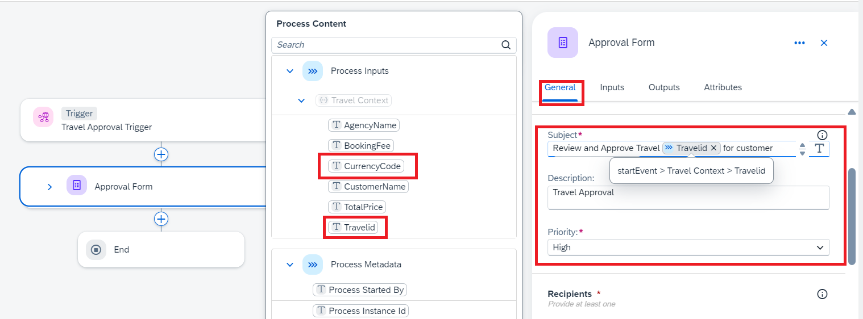

1. Set the **Recipient**, detail of the user who would receive the approval form in their inbox for approval.

Multiple valid email addresses can be added separated by commas in the below fields.

It is mandatory to fill one of the fields users or groups. We are filling Users field here.

| **Fields** | **Values** |
| --- | --- |
| Users | **Process Started By** [Select **Process Started by** from Process Metadata], abc.xyz@sap.com |

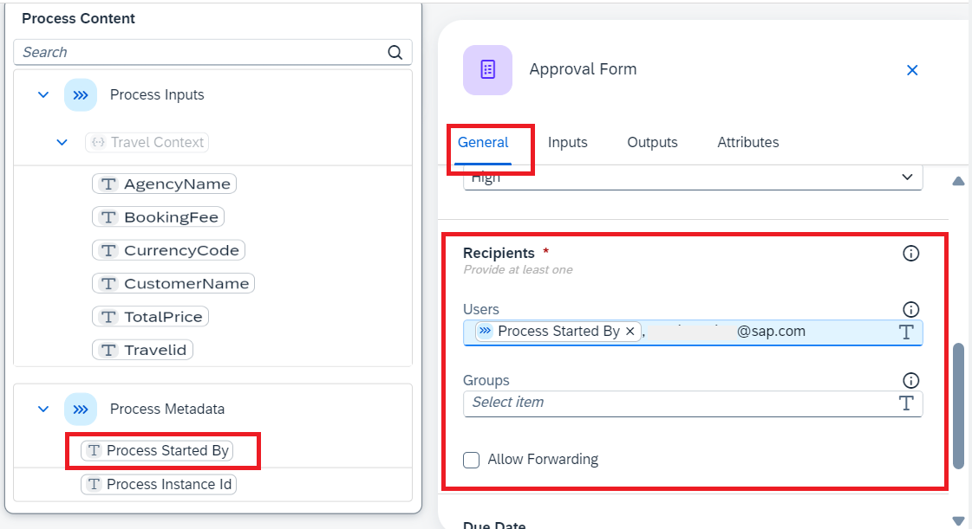

1. In the Due Date section:

Select Static Duration as type of due date.

Enter 2 Days as the duration.

As the task appears in the MyInbox, there will be duration information shown to the recipients like Overdue if the task was not completed in 2 days, or within 1 day if the task is supposed to be completed in 1 day etc.

This means that the due date to approve or reject the form will be set to 2 days.

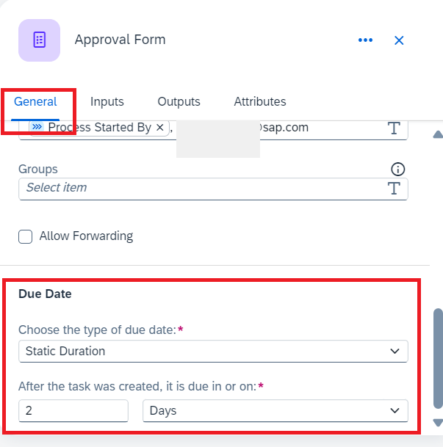

1. Similarly, go to the **Inputs** section and map the different input fields, which were marked as read-only in the approval form, by selecting the respective **Process Content** entry.

| **Form Input Fields** | **Process Content Entry** |
| --- | --- |
| Travel ID | Travelid |
| Agency Name | AgencyName |
| Booking Fee | BookingFee |
| Currency Code | CurrencyCode |
| Customer Name | CustomerName |
| Total Price | TotalPrice |

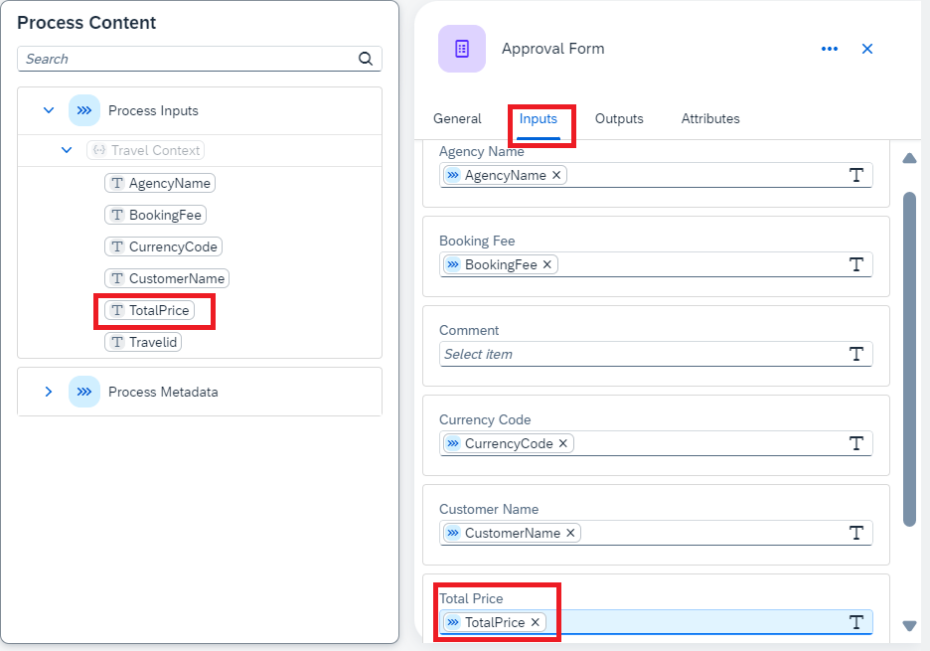

The process content will highlight the entries with the same data type of the input field. For example: if the input field is of Number type, then Process Content will show only number-type entries.

*The process content will highlight the entries with the same data type of the input field. For example: if the input field is of Number type, then Process Content will show only number-type entries.*

1. Save the process.

The process should look like below:

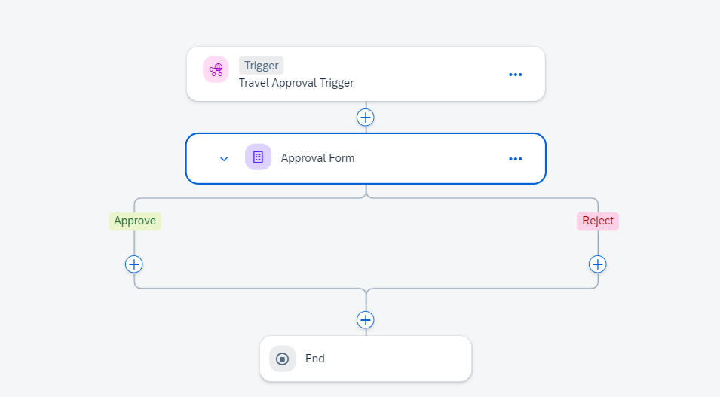

### **Step3: Test Yourself.**

Can you combine plain text and process content attributes in the subject of a form?

* Yes, of course.
* No, that is not possible.

## **Group 2: Tutorial 4**

## **Create and Configure Action in the process flow.**

Beginner 30mins

[SAP Build Process Automation, Beginner, Tutorial](https://developers.sap.com/tutorial-navigator.html?tag=software-product%3Atechnology-platform%2Fsap-build%2Fsap-build-process-automation&tag=tutorial%3Aexperience%2Fbeginner&tag=tutorial%3Atype%2Ftutorial), [SAP Business Technology Platform](https://developers.sap.com/tutorial-navigator.html?tag=software-product:technology-platform/sap-business-technology-platform/sap-business-technology-platform)

Create an action project from Open API specification.

You will learn.

* To create and configure action project based on the API specification.
* To release and publish action project to be consumed in the business process modelling.
* To add action to the business process.
* To map input fields of the action to the actual process content
* To release and deploy business process with actions.

Prerequisite:

* Complete Group 2, Tutorial1, 2 and 3.

Owner: [Ruchi Dobriyal](https://github.com/RDobriyal)

Action is a feature in **SAP Build Process Automation** to connect processes with external systems, be it SAP or non-SAP systems. This is an important piece of the puzzle especially if you want to automate or extend your business processes for any available LoB processes like S/4HANA, SAP BTP ABAP Platform, SuccessFactors etc. These extensions can be easily built using SAP Build Process Automation, and using actions you can connect to your given S/4HANA, SAP BTP ABAP Platform, Ariba or other SAP LoB systems for any kind of GET, POST, PATCH, and other calls.

In this tutorial, you will create an action project based on Open API. The **Workflow Notification API** is an OData V4 service available to send the notification at the completion of a workflow step back to the calling system. You will use the **POST call from SBPA to BTP ABAP environment to notify if the travel request has been Approved or Rejected on completion of workflow.**

### **Step1. Create an Action Project.**

1. Open **SAP Build Lobby** with your username and password, then do the following:

* Under **Connectors**, select **Actions**.

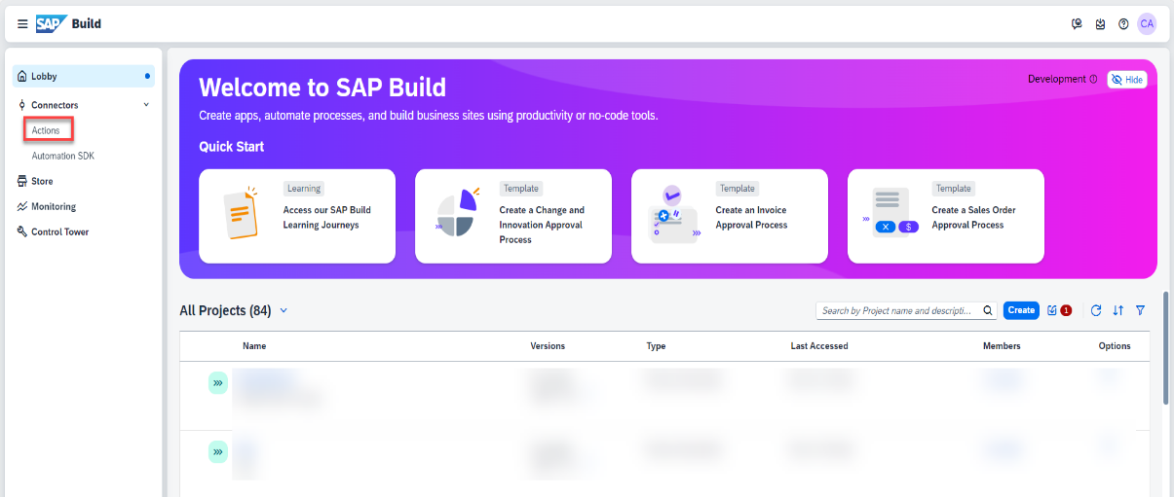

1. **Save** the below **Open API Specification** file as local **.edmx file**.

Source Code:



1. Choose **Create**.

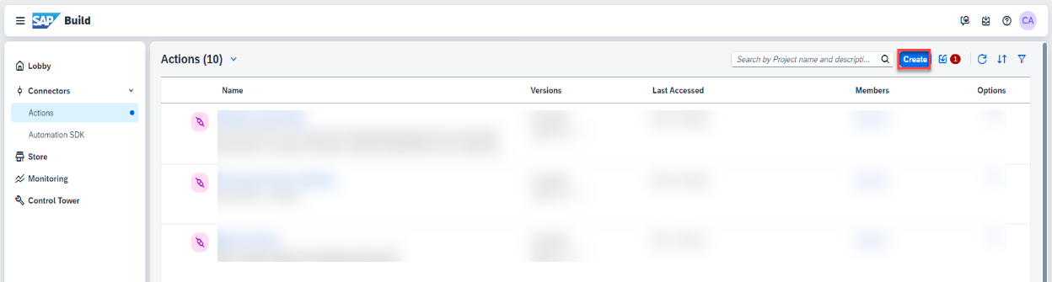

1. In the **Choose an API Source** popup, under **API Specification**, select **Upload API Specification**.

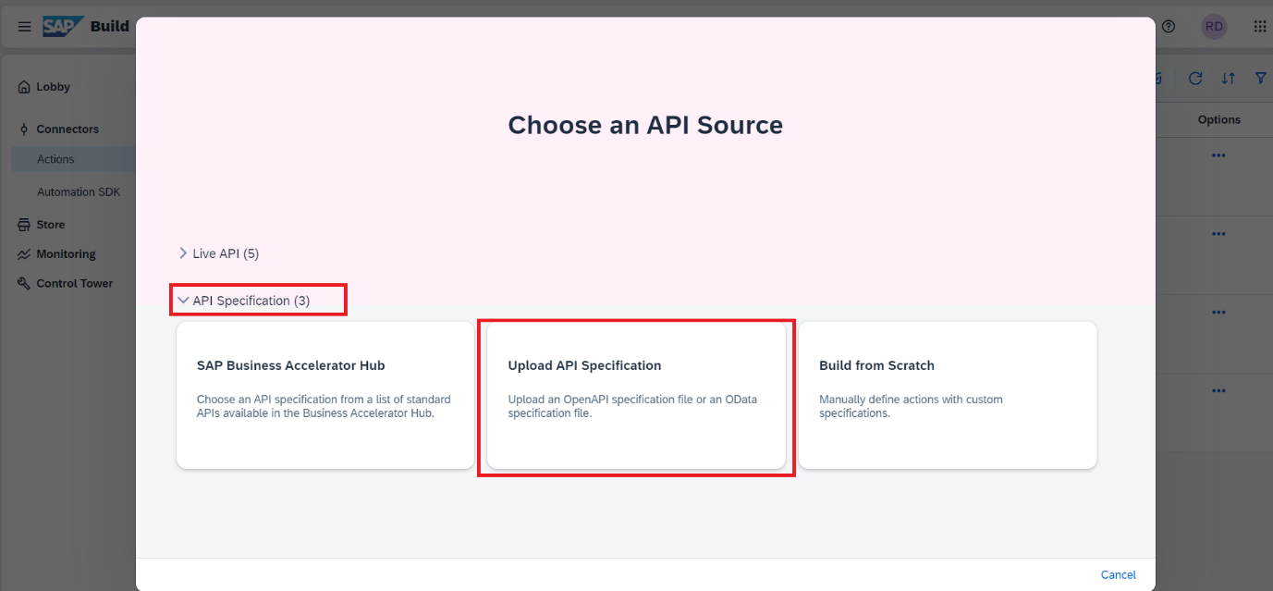

1. Drag and drop or click **Browse Files** to upload open specification file saved in step above.
2. Choose **Next**.

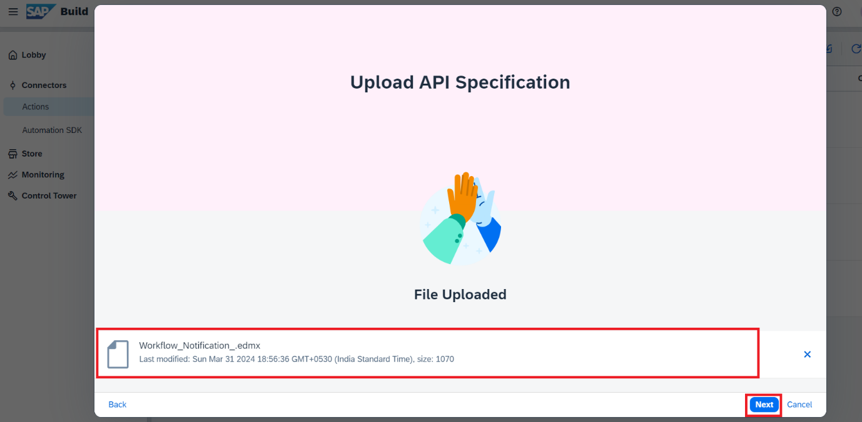

1. In the **Create an Action** project popup, do the following:

Enter the **Project Name** as **Workflow Notification**.

Enter the **Description** as **Workflow Completion Notification**.

Click **Create**.

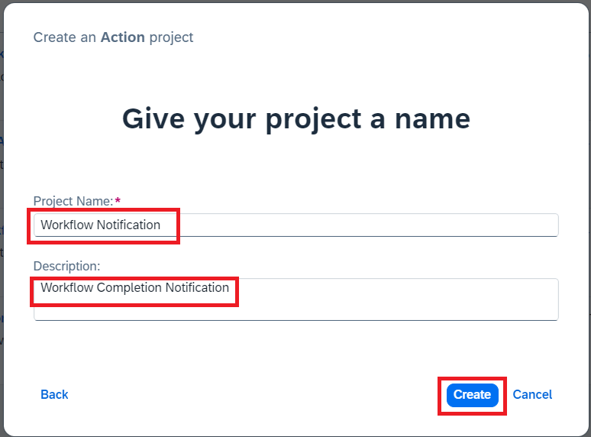

As soon as the **Workflow Notification** Action gets created, SAP Build Actions will automatically open and the **Add Actions to Workflow Notification** pop up will appear.

1. **Select** Service Operation **Post**. Click on **Add**.

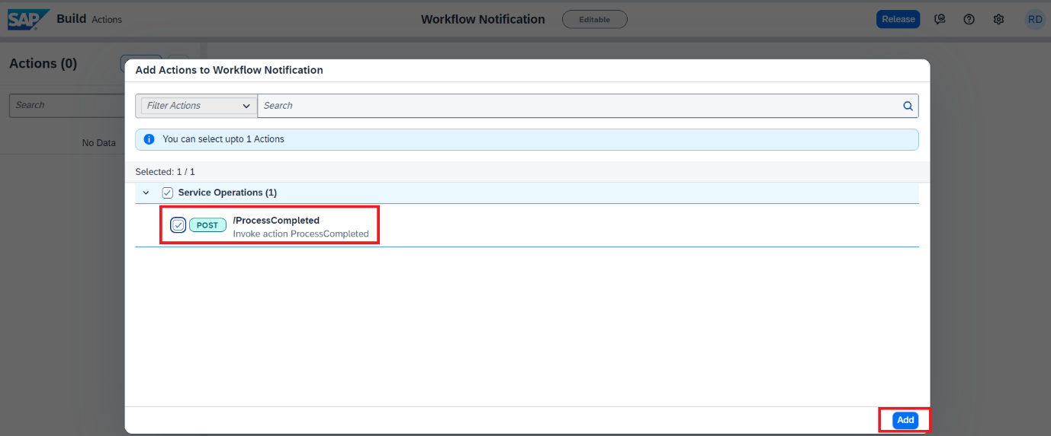

1. SAP Build Actions will open with the selected APIs which can be further configured based on the requirements.

* To update the project name, click on the **pencil icon** next to the project name.

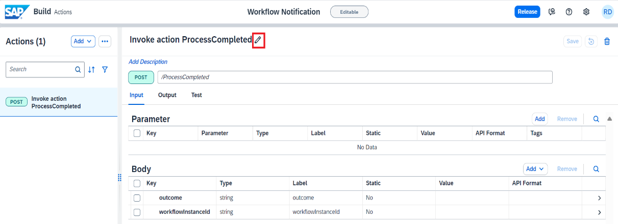

*This action project name will help you search your action project from your API list, once published in action repository.*

* Change the name to **Workflow Completion Notification**.
* Once done, select **Update** to submit the changes.

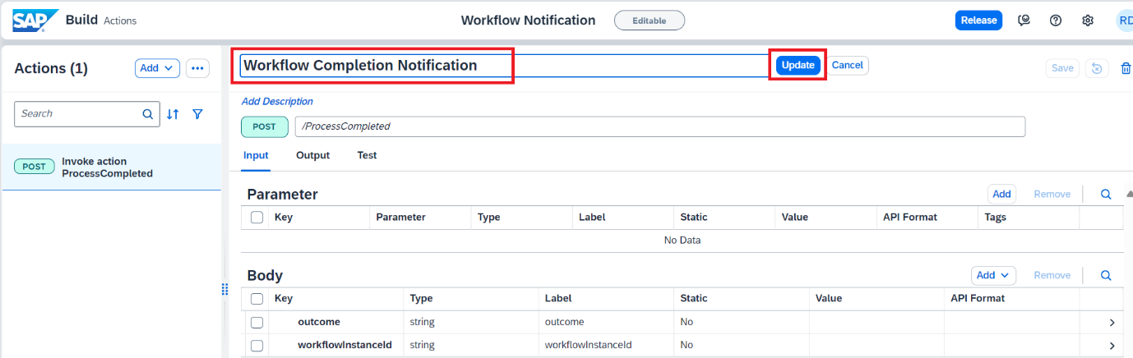

* Enter the default value for **outcome** Input field by clicking on it.

**Set** the value for **outcome** to **Approved**.

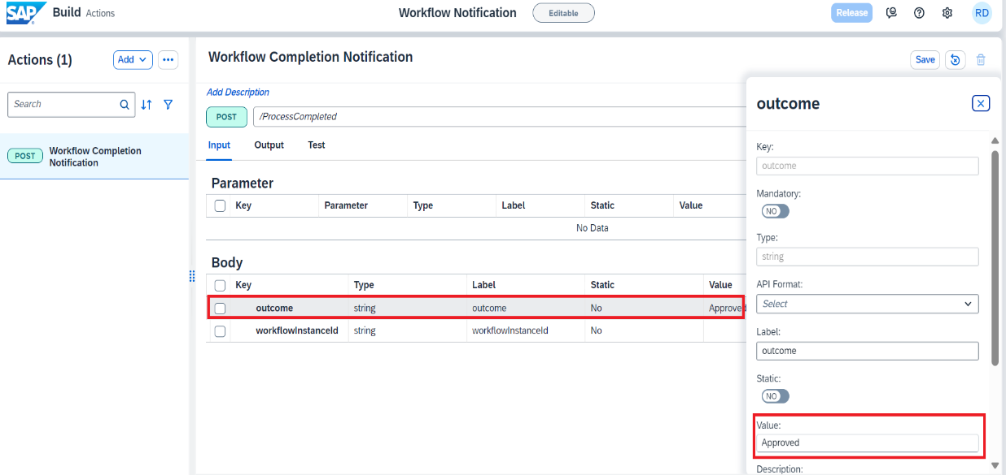

It is also possible to change the field lables and update the input/output fields of the action project to keep only the mandatory fields that are needed.

* As BTP ABAP environment APIs need CSRF token, you need to enable it. Select **Settings** icon.

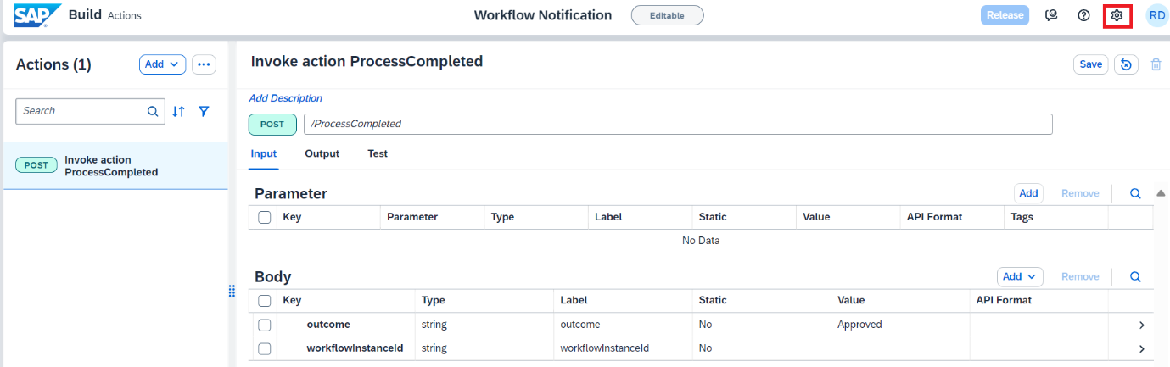

* In the **Project Settings** window select **CSRF** and do the following:
  + **Enable CSRF** by selecting **YES**.
  + Under the **Token Fetch End Point**, enter: **/**

**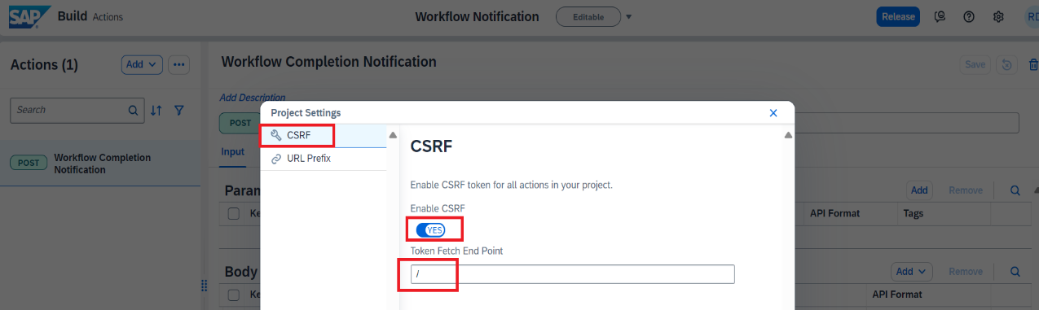**

* In the **Project Settings** window select **URL Prefix** and do the following:
  + **Enter Resource Path** “/sap/opu/odata4/sap/api\_workflow\_notification/default/sap/api\_workflow\_notification/0001”.
  + Choose **Save.**

*Resource Path is required to create the* ***Final Action******URL*** *by combining*{Destination URL} + {Resource Path} + {API Endpoint}

*If you're exposing multiple services from the same system, you don't have to create different destinations to access those services. By configuring the resource path, you can set only one destination.*

*Resource paths must begin with / and can't end with /.*

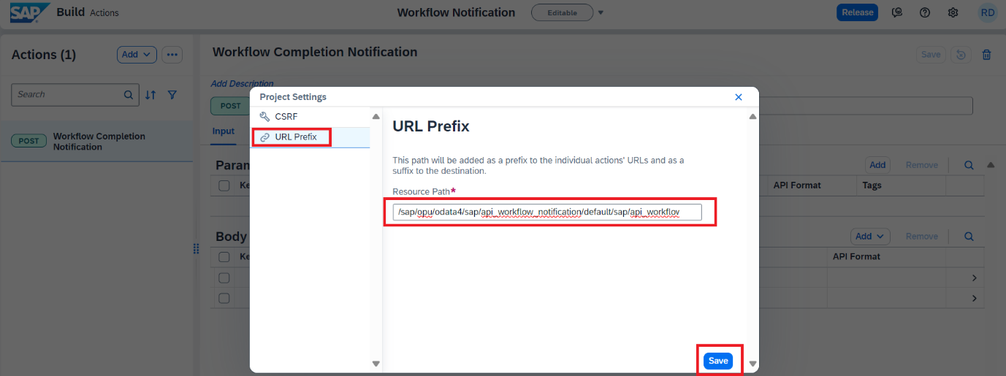

*If you get Gateway Timeout issue while saving, then close the error dialog and refresh the browser.*

*If you see that changes are not saved, then try saving again and refreshing the browser.*

1. **Save** the Action Project.

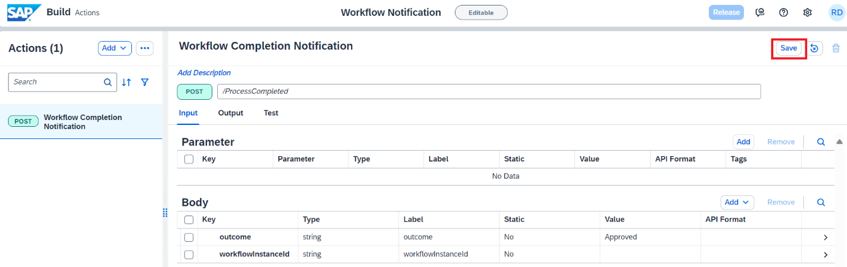

1. **Release** the action Project.

You will now release the action project to create version(s) and then publish a selected version in the action repository. It is then these published actions that can be used in different processes and applications to connect to external systems.

* To release a version of the action project, click Release from top-right corner.
* Enter the **Release Notes: “Workflow Completion Notification V1”**

*Notice the version of the project. It is in*majorVersionNumber.minorVersionNumber.patchNumber *format.*

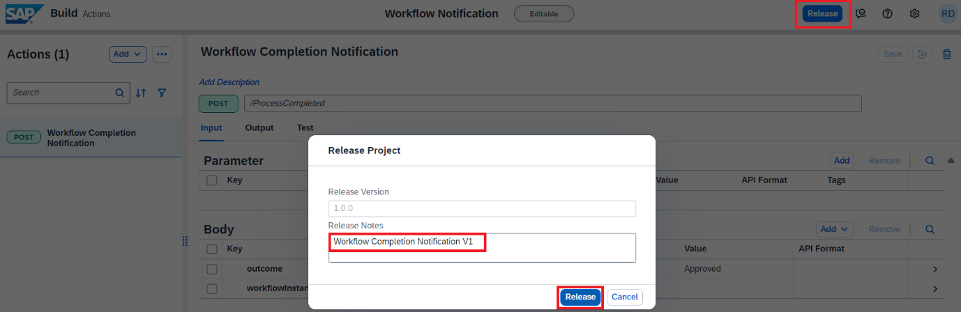

1. **Publish** Action Project.

Once the action project is released, you can then publish any release version of the action by clicking **Publish to Library** from top-right corner.

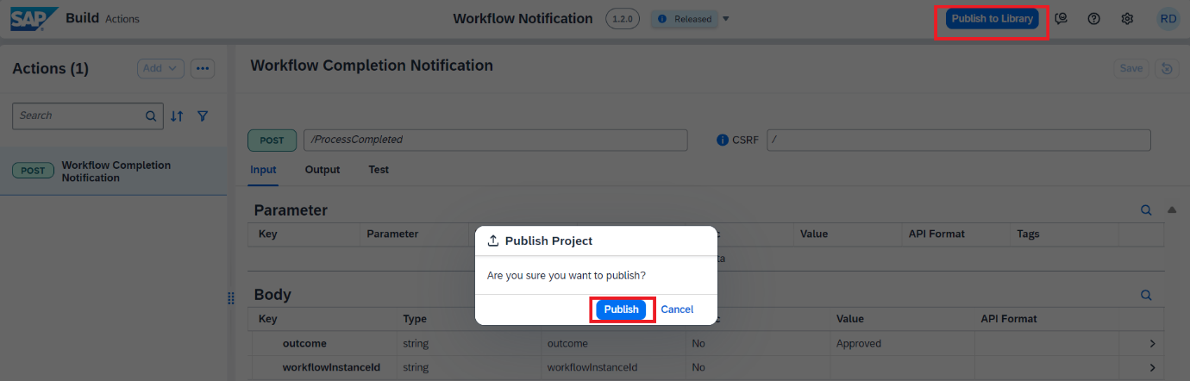

With this you have successfully completed creating, configuring, releasing, and publishing of action project. Now you will use this published action to connect workflow business process to external systems via API.

### **Step2. Add Action Project to Business Process.**

Add the action in the business process to connect and send the workflow completion notification back to the system that triggered the workflow. You can do this by choosing the relevant action from the action’s library, and then configuring the action’s parameters.

* + 1. Go to **lobby** and **open project** RAP110\_Travel\_Workflow. Navigate to open the process builder canvasfor **Travel Approval Processing** and click on **expand ‘>’** for the **Approval form.**

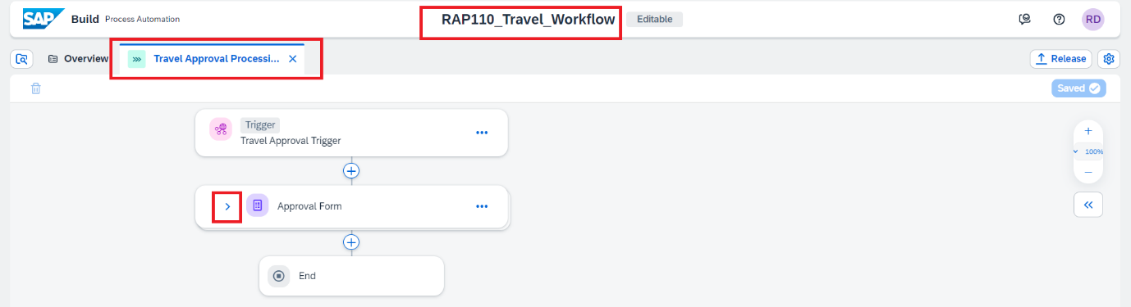

* + 1. To **add** the callback **action** once the form is Approved, click on the **+** on the **Approve** branch.

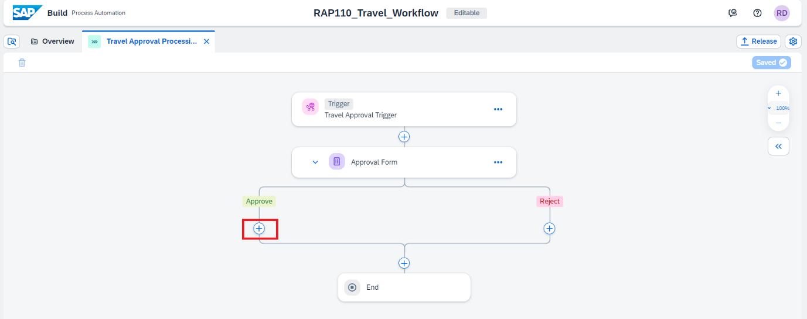

* + 1. From the options select Action.

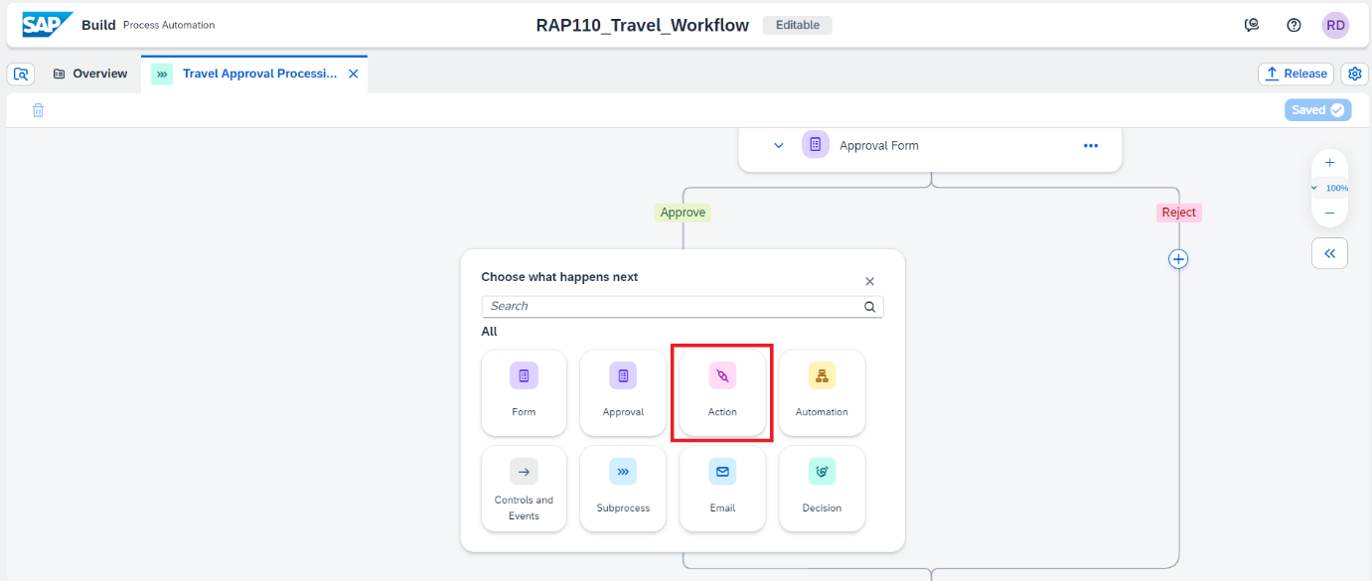

* + 1. In the **Browse Action** library pop up, enter the action name that you just created like in this case ‘**Workflow Notification**’ in the **Search** field, to find the actions published by you in the library. Once you find your action project click on **Add**.

This will add the action to your business process.

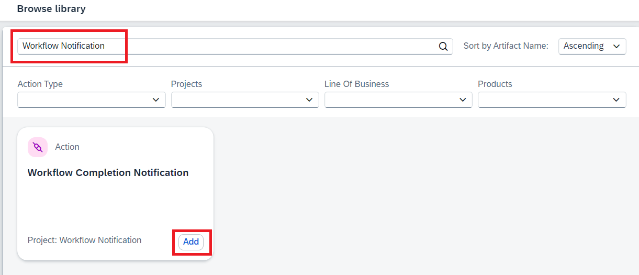

* + 1. Configure Action for Approval.

On clicking the add button your action will be added to the business flow and a **pop-up**

**window** will open to **configure the action settings** for Destination, Input, and Output parameter mapping.

In **General tab** of action parameters, expand **Destination** variable and choose **+Create**   **Destination Variable.**

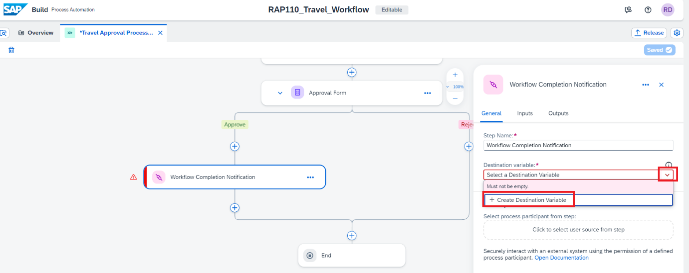

* + 1. In the pop-up window for **Create Destination Variable**, fill in the below **values** and choose **Create**.

| **Input Field** | **Value** |
| --- | --- |
| Identifier | Callback\_Destination |
| Description | Callback Destination |

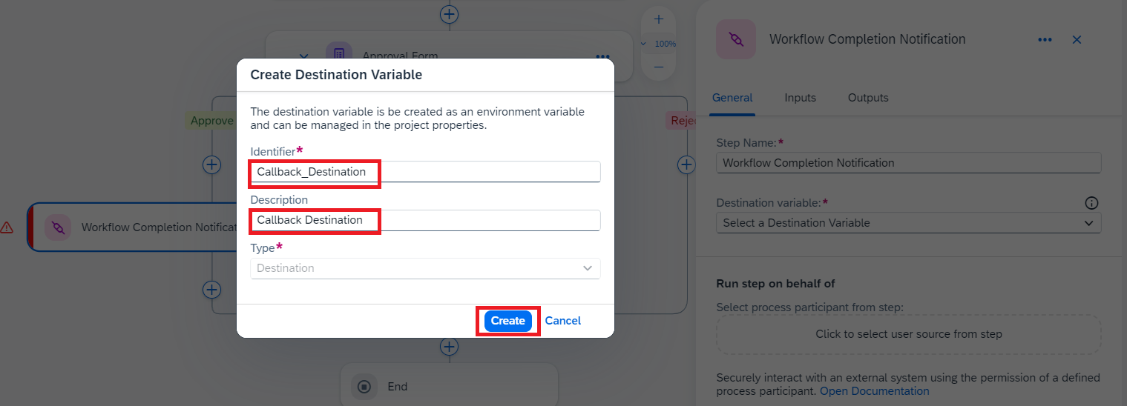

*A Destination variable is required to connect the action to a configured system. The actual destination value is selected on the deployment of the Business Process.*

* + 1. Click **Inputs** tab and map each input to the actual process content.

Please note that since the **default** value for **Outcome** is set to **Approved** in the Action Project, we will not be setting it here.

To set the value for **WorkflowInstanceId**, click on the field and select **Process Instance ID** from the **Process Metadata**.

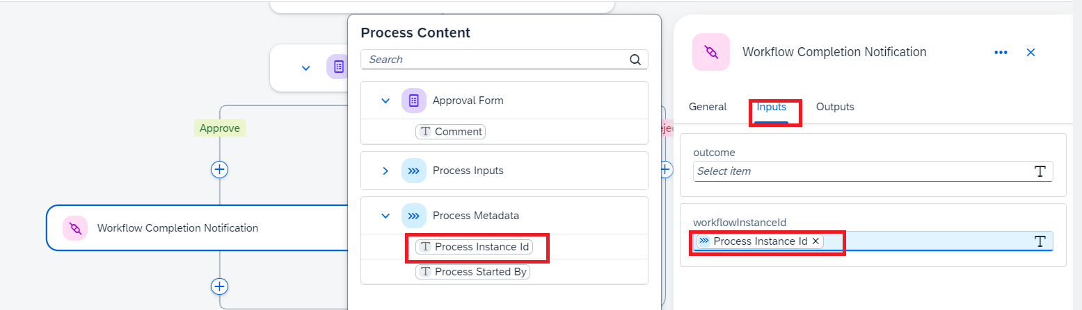

* + 1. To call the action in case the **Approval form** is Rejected, click on the **+** on the **Reject** branch and follow all the steps described above for the Approve branch to add the action.
    2. Once the **Action** is added to the **Reject branch**. In **General tab** of action parameters, expand **Destination** variable and choose the destination **Callback\_Destination** you already created.

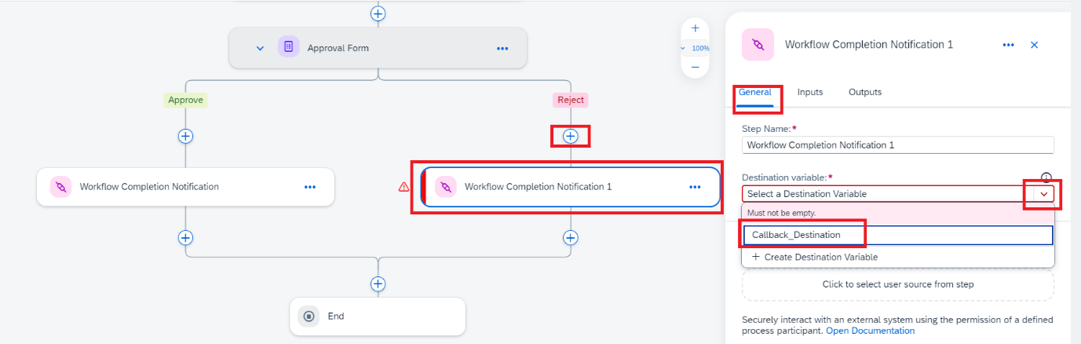

* + 1. Click **Inputs** tab and map each input to the actual process content for the **Reject branch** action trigger.

As the **default** **Outcome** is Approved, we will have to change the value in case of Approval form **rejection**.

| **Input Field** | **Value** |
| --- | --- |
| Outcome | Map it to the Approval Form output field **Comment** |
| WorkflowInstanceId | Map it to the field **Process Instance id** under Process metadata |

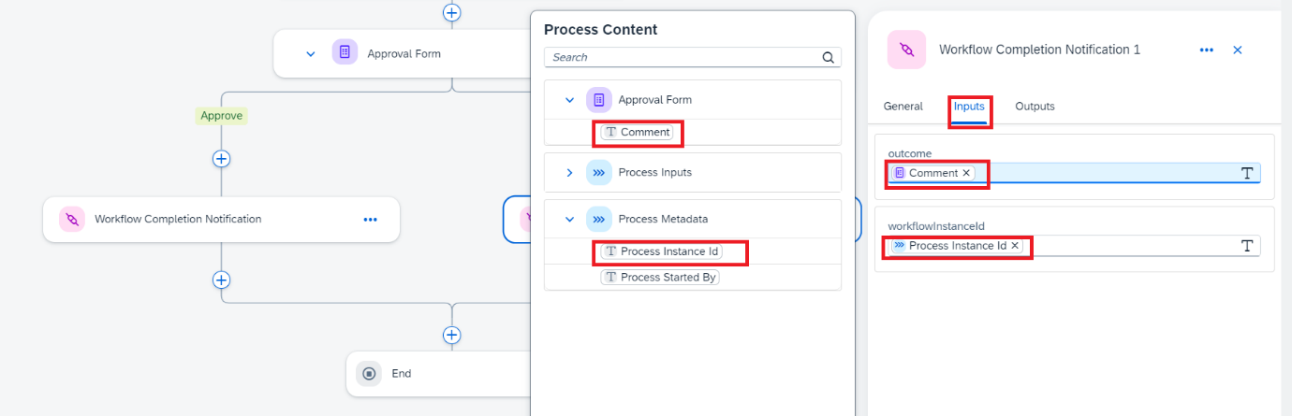

* + 1. **Save** the Business Process.

The final process should be same as shown below.

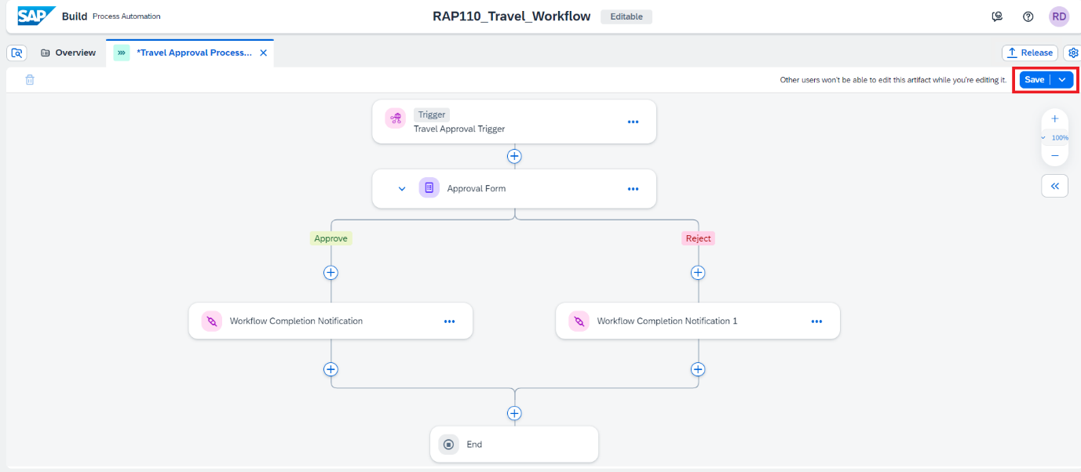

### **Step3: Test Yourself.**

What is the mandatory operation for action project to be consumed in business process?

* Save
* Publish
* Release
* Export

## **Group 2: Tutorial 5**

## **Release and Deploy Business Process Project.**

Beginner 10mins

[SAP Build Process Automation, Beginner, Tutorial](https://developers.sap.com/tutorial-navigator.html?tag=software-product%3Atechnology-platform%2Fsap-build%2Fsap-build-process-automation&tag=tutorial%3Aexperience%2Fbeginner&tag=tutorial%3Atype%2Ftutorial), [SAP Business Technology Platform](https://developers.sap.com/tutorial-navigator.html?tag=software-product:technology-platform/sap-business-technology-platform/sap-business-technology-platform)

To Run the Business Process Project, you need to first release and deploy it.

You will learn.

* How to release, deploy the Process

Prerequisite:

* Complete Group 2, Tutorial1, 2,3 and 4.

Owner: [Ruchi Dobriyal](https://github.com/RDobriyal)

Till now you have created and saved your business process project along with the callback action. You will now release and deploy your project. The **release** process allows for **semantic version control** with format X.Y.Z. **Deploying** your project will allow you to **set the proper parameters** like **destination**, if necessary, to allow for project execution.

There are two possible situations during Release:

* When you are releasing a **new** business process project, enter a summary of the changes in the Release Notes (optional) then choose Release.
* When you are releasing a **modified** version of a business process project that is already released, in the release Version Contains dialogue, select one of the following:
  + Select **Bug Fix** to indicate bug fixes. It updates the third **digit (Z)** of the version number.
  + Select **Minor Changes** to indicate small modifications. It updates the second **digit (Y)** of the version number.
  + Select **Major Changes** to indicate important modifications potentially leading to incompatibility between versions. It updates the first **digit (X)** of the version number.

### **Step1. Release Business Process Project.**

Releasing a project creates a version or snapshot of the changes.

1. In the Process Builder, choose **Release on the top right corner**.

Add a **Version Comment** if needed and choose **Release**.

**Note:** You are releasing the Project for the first time thus the version starts with 1.0.0. The next time you release there will be options to choose from – that is, if the new version is a major, minor, or patch update; version numbers will be automatically updated.

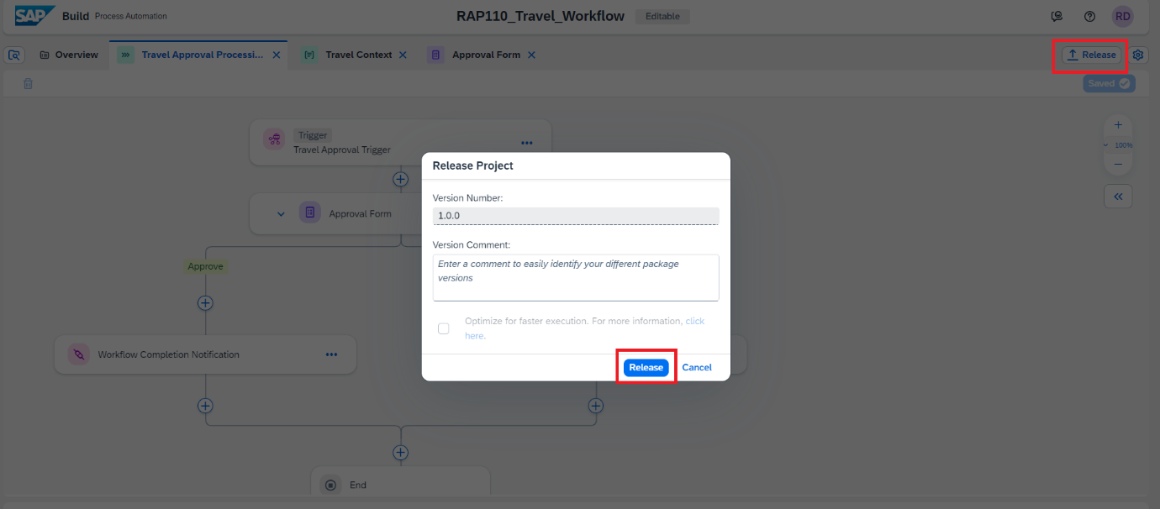

1. The project released successfully and is ready to be deployed.

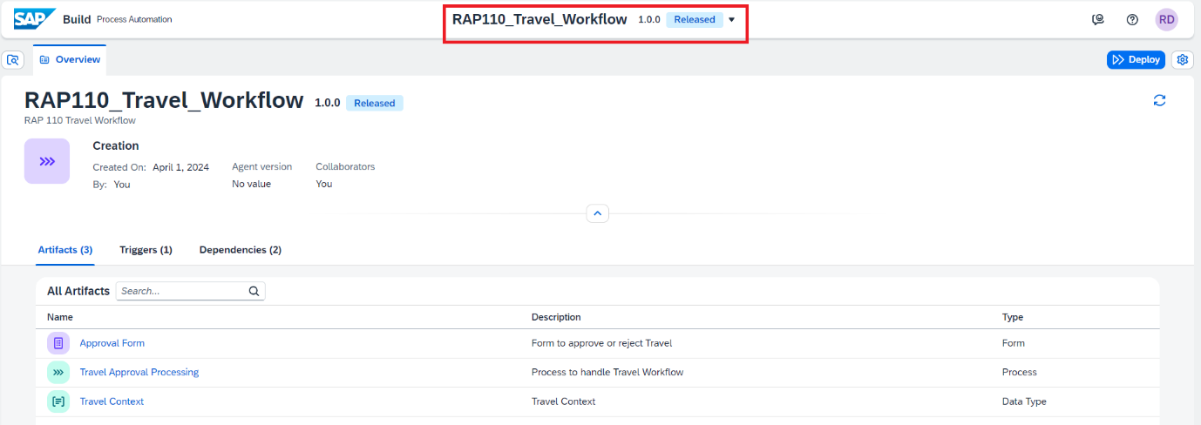

### **Step2. Deploy the released Business Process Project.**

You can deploy Business Process projects from each released version of the project in the Process Builder or through the Lobby. Deploying the project makes it available for others to use it. Please note that you can only deploy a released version of the project.

1. From the released version of the Business Process project in the Process Builder, choose **Deploy** > Select Environment **Public** > choose **Deploy**.

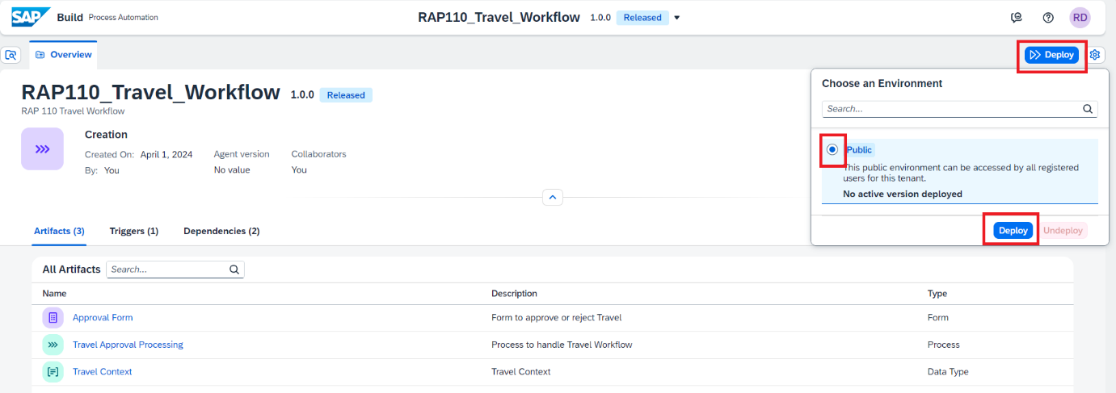

Deploy will take a couple of seconds/minutes depending upon how big your project is and how many different skills it has. Any errors during the deployment will be shown in the Design Console.

1. You will now set the **runtime variables**. From the drop-down select the destination **abap-cloud-dev-steampunk-canary** and click **Deploy**.

**Note:** This is the callback destination that we created in BTP Subaccount and pulled in SAP Build Process Automation as part of Tutorial **– “Give the link of Group 1 Tutorial 1”.**

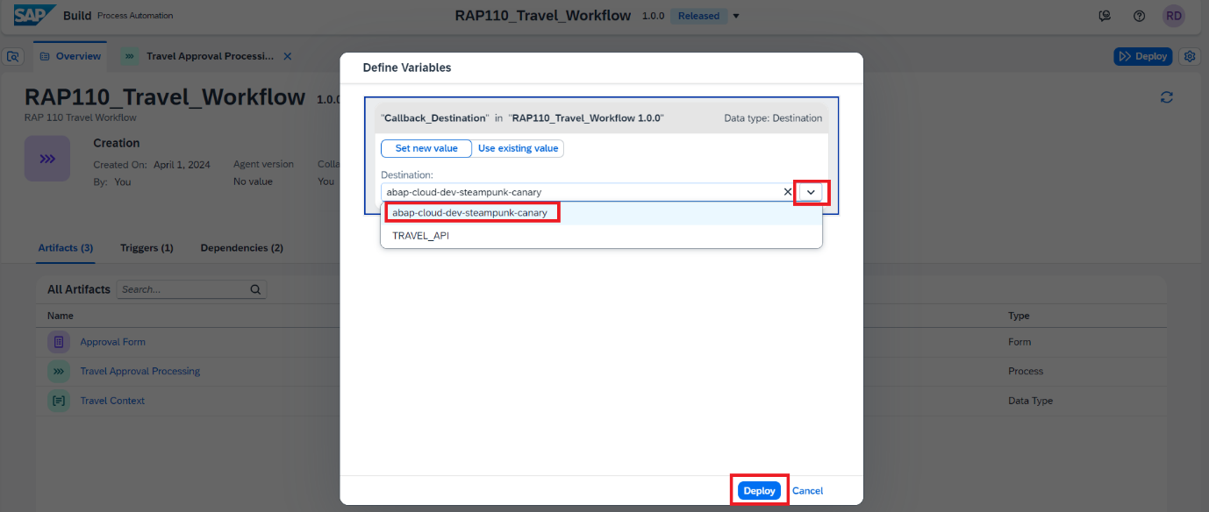

*Variables allow you to reuse certain information for a given business process project deployment.*

*You use variables to pass parameters to automations. You can create variables in the Process Builder for which you can later set values when deploying the business process project. For example, in the current use case, you have created a Destination variable.*

1. The successfully deployed project is ready for running and monitoring.

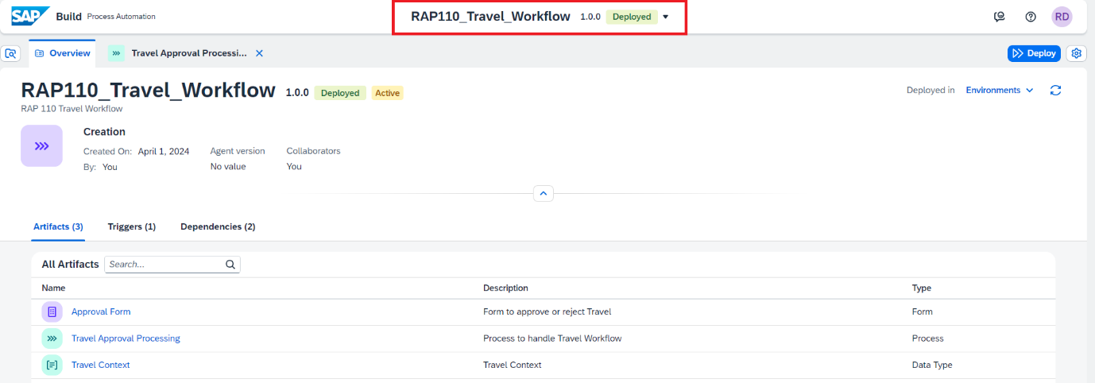

### **Step3: Test Yourself.**

Before Calling the Workflow Process from BTP ABAP Environment what action needs to be performed?

* Deploy the Process
* Work on the Tasks
* Monitor the Process
* Run the Process

# **Group 3**

## **Create and Extend your RAP Application to trigger workflow in SAP Build Process Automation**

4 Tutorial 1 hr 15mins

[BTP ABAP Environment, Tutorial, Intermediate, SBPA Workflows](https://developers.sap.com/tutorial-navigator.html?tag=tutorial%3Aexperience%2Fintermediate&tag=tutorial%3Atype%2Ftutorial&tag=programming-tool%3Aabap-exte)

This section explains how to extend a RAP business object with behaviour extensions. The BO will be extended with **determination on save** which will **trigger** the **workflow in SBPA** using **RAP Façade**. This section also explains how to handle callbacks from SAP Build Process Automation to receive workflow completion notifications.

### **Tutorials**

* Create and Implement workflow handler class.
* Extend the RAP Application to integrate workflow capability.

## **Group 3: Tutorial 1**

## **Create and Implement the Workflow Handler Class.**

Intermediate 45mins

[BTP ABAP Environment, Tutorial, Intermediate, SBPA Workflows](https://developers.sap.com/tutorial-navigator.html?tag=tutorial%3Aexperience%2Fintermediate&tag=tutorial%3Atype%2Ftutorial&tag=programming-tool%3Aabap-exte)

You will learn.

* How to create a workflow handler class.
* How to enable it to receive callbacks.
* How to call RAP Façade for SBPA workflow trigger.
* Methods to use to get trigger data and process callbacks.

Owner: [Ruchi Dobriyal](https://github.com/RDobriyal)

Prerequisites

* You have bought a licensed version of SAP BTP ABAP Environment.
* Latest Version of ADT with abapGit plugin.

<https://eclipse.abapgit.org/updatesite/>

* Make sure, your system has the ABAP flight reference scenario by searching for package **/DMO/FLIGHT**. If your system does not have this scenario. You can download it [here](https://github.com/SAP-samples/abap-platform-refscen-flight).
* [Generate a RAP Business Service with the wizard.](https://developers.sap.com/tutorials/abap-environment-rap-generator.html#fc3f99be-39fc-41f8-9251-8647ef04434b) – Follow the tutorial to create a travel App.

Once you have created a basic RAP Travel Application by following steps in tutorial [Generate a RAP Business Service with the wizard.](https://developers.sap.com/tutorials/abap-environment-rap-generator.html#fc3f99be-39fc-41f8-9251-8647ef04434b) You would now create a new class in the application package to handle workflow related implementations i.e., method to **create workflow trigger** and method to **handle callbacks** to **receive outcome** of workflow from SAP Build Process Automation once the process is completed.

In case of **Travel Approval Workflow,** the callback applies the accept / reject decision of the workflow to the Accept Travel /Reject Travel statuses of the related travel instance.

### **Step1. Create a workflow handler class.**

The workflow handler class will contain all the method implementations, constants, interface data types to exchange information with SAP Build Process Automation for workflow.

To create the class, follow the below steps:

1. Right click on your **Package** and select **New > ABAP Class.**

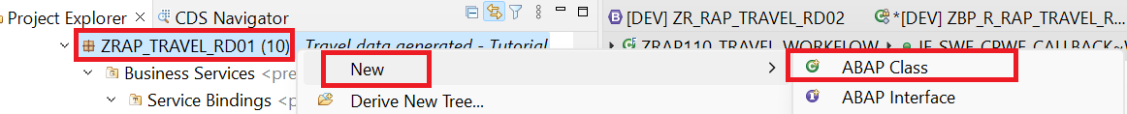

1. Enter the below values to create the class.

Name: ZCL\_R\_RAP\_WORKFLOW\_####

Description: Workflow Handler Class

1. Click Add to enter Interface and search for callback Interface ‘**IF\_SWF\_CPWF\_CALLBACK****’**. Click **OK** once found.

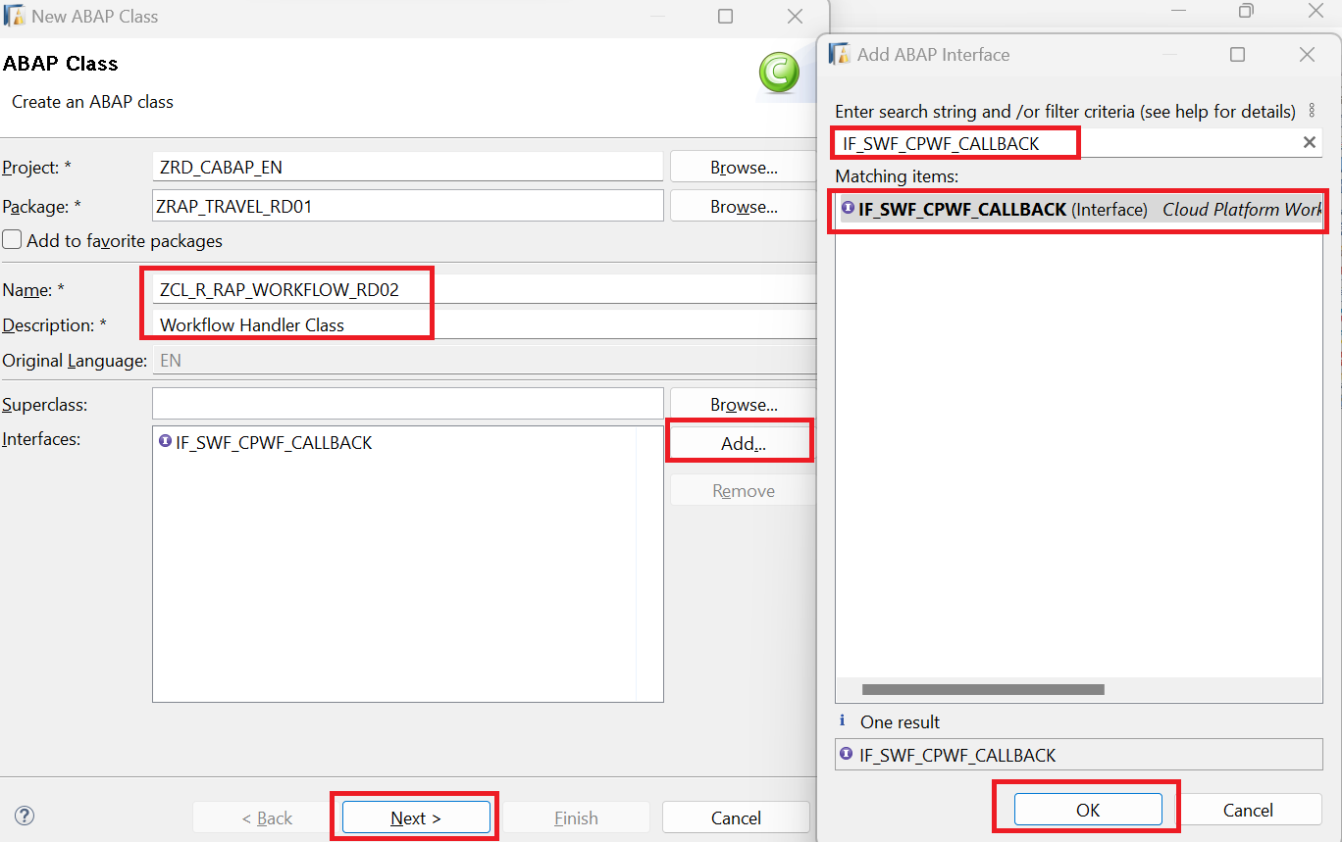

1. Click **Next**. Select the **transport request** for your application and click **Finish**.
2. Class is now **created**. You can see that the interface addition came with the method **workflow\_instance\_completed** which would be triggered during callback post completion of workflow in SBPA.

In the later steps we would implement this method to receive workflow decision/notification.

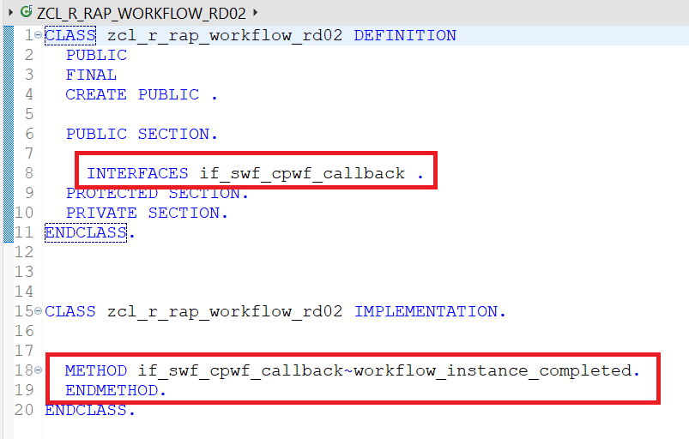

Thus, to enable a class to be callback class we need to add Interface **IF\_SWF\_CPWF\_CALLBACK** to it.

***IF\_SWF\_CPWF\_CALLBACK*** *is the interface required to handle callbacks. The method* ***WORKFLOW\_INSTANCE\_COMPLETED*** *of this interface is triggered in* ***background*** *once the* ***Action Workflow Completion Notification*** *is triggered in* ***SAP Build Process Automation*** *Post Approval Form is acted upon by the Approver (Accepted/Rejected).*

*To troubleshoot/debug this method you would use the Background workflow user* ***‘SAP\_WFRT’****.*

### **Step2. Enrich the class definition with Constants and Data Types and Methods.**

Define the class artifacts required for workflow processing.

1. Define Context (Interface) Data type in the private section of the class. **Insert** the below code.

This should be same as the data type context structure declare in SAP Build Process Automation.

ABAP Code:



Since the Datatype identifier name created in SBPA is **TravelContext** thus we have also declared the structure name as **travel\_context**. How the name conversion works when we convert from ABAP data to JSON format will be explained in detail as we go through the tutorial.

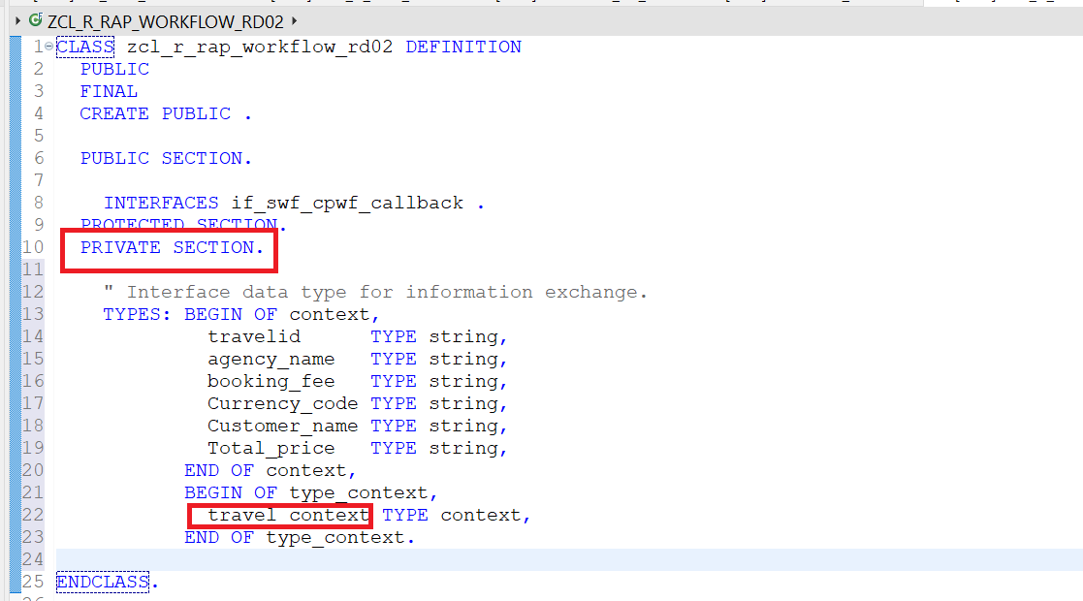

*Please* ***note****,* ***Context*** *(Interface Data) must have the same field datatypes and names on both sides of the Interface. Context is case sensitive, so any deviation would lead to error.*

*HTTP request for use case START\_WI failed (HTTP code 422, Reason 'Unprocessable Entity')*



1. Get the workflow definition ID from SAP Build Process Automation.
2. Login to SAP Build Process Automation.
3. Navigate to Monitoring > Processes and Workflows

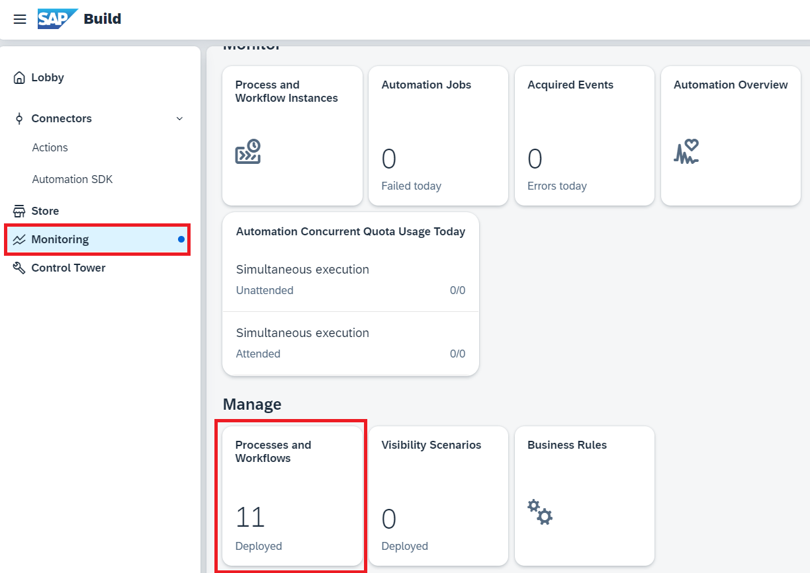

1. **Choose** your **project** name from the **drop down** > **Select** the **project name**.

**Copy** the entire text in **ID** highlighted below, that is your **Workflow Definition ID**.

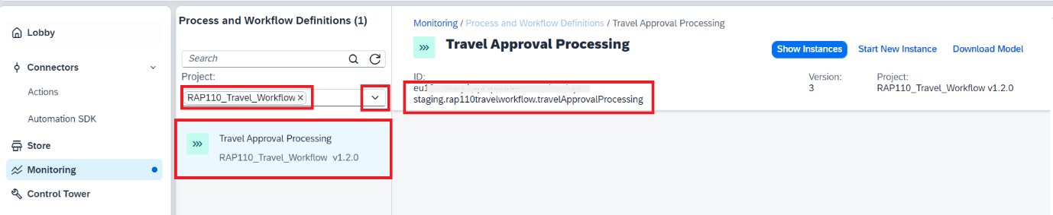

1. **Define Constants** in the private section of the class. **Insert** the below **code**.

ABAP Code.



*Please Note: Do not forget to replace the values for* ***workflow definition ID*** *&* ***Callback class*** *values for your implementation.*

| **Constant Name** | **Use** | **Values** |
| --- | --- | --- |
| Travel\_status | To store the allowed value of the overall status of a **Travel** instance. | Possible values can be Open (O), Approved (A), rejected (R) and Awaiting Approval (W). |
| wf\_retention\_days | Retention time is the time we keep the database entry post completion of Workflow instance. After the retention days are passed the database entry will be deleted automatically.  In case the retention time is set to 0, the entry would not be deleted automatically but would require an API call for deletion. | Set the retention days to '30'. |
| callback\_class | Class, we created with callback interface, to be used while Registering the SBPA Workflow using RAP Facade | Set the Value to 'ZCL\_R\_RAP\_WORKFLOW\_XXXX' |
| consumer | Tells the information on where to trigger the workflow.  In the Communication Arrangement for SBPA we have set the consumer type (Workflow) as default. | Set the Value to 'DEFAULT'.  As we need to execute the workflow in SBPA |
| travel\_wf\_defid | Is the Definition ID of the workflow we created in SBPA | Set the value to the Workflow definition ID retrieved from SBPA. |

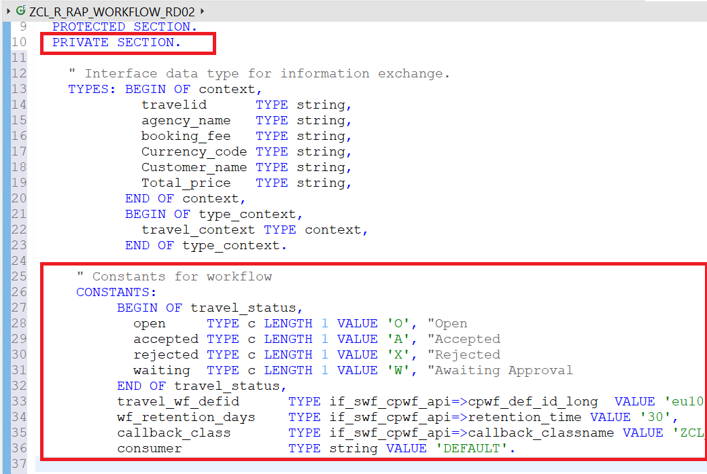

1. Define Method to trigger workflow in public section.

The method interface will consist of all the **travel\_context**  fields declared in the datatype.

It is declared in the public section of the class so that it can be called from the behaviour definition class of the RAP Business Object.

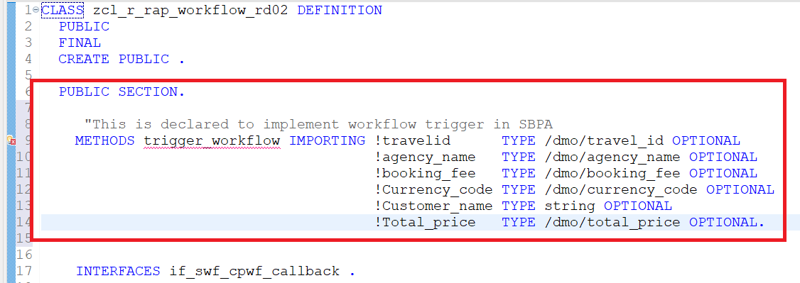

1. **Click** on the **Quick Assist** available on the left side of the newly defined method > **Click Add implementation for trigger workflow**.

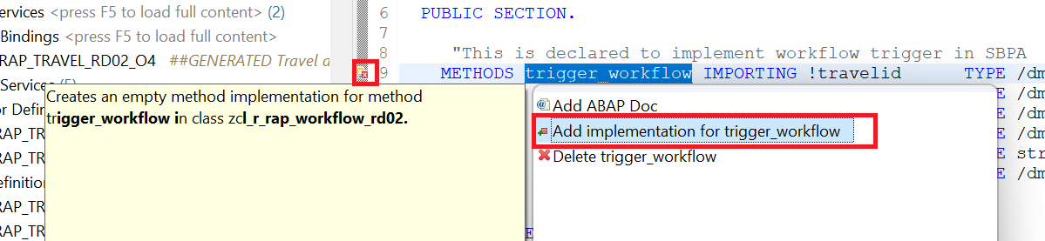

1. This will create the method in the implementation section of the class. As shown below.

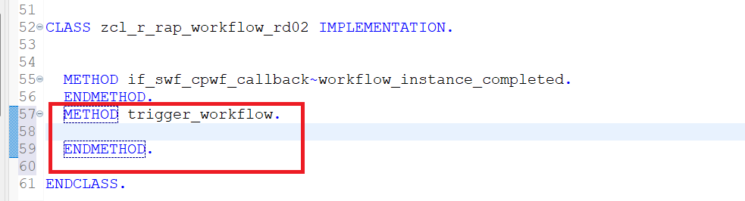

1. Activate  the class.

### **Step3. Implement methods to trigger workflow in the Class Implementation Section.**

Implement the method  trigger\_workflow to call the RAP façade  I\_CPWF\_INST using EML (Entity Manipulation language).

With the released Business Object Interface, I\_CPWF\_INST you can trigger workflow out of your BTP ABAP environment like in this case in SAP Build Process automation.

*The Entity Manipulation Language (EML) is an extension of the ABAP language which offers an API-based access to RAP business objects. EML is used to implement the transactional behavior of RAP business objects and, also to access existing RAP business objects from outside the RAP context.*

Insert the following code snippet in the method. You can use the **F1 help** to get detailed information on each EML statement.

ABAP Code:



Your method would look like this:

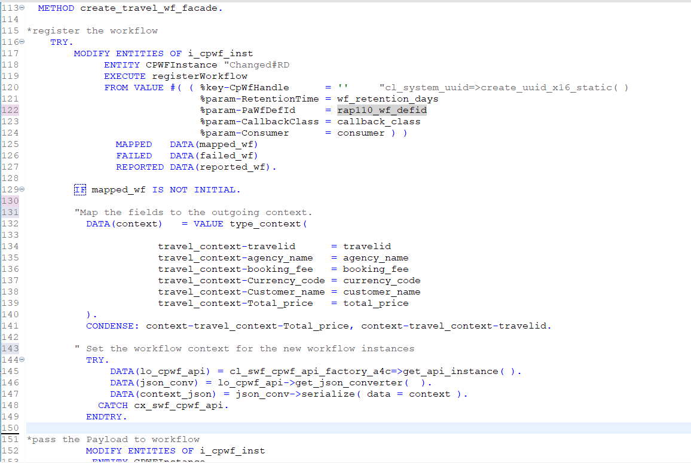

**Short explanation of the flow logic:**

1. First step is to **Register the workflow**.

This is done by using the **EML** Operation **MODIFY ENTITIES** on RAP Business Object Interface (RAP Façade) I\_CPWF\_INST, Entity  CPWFInstance to execute **Register Workflow action** of the BO interface  I\_CPWF\_INST with the below input parameters.

* **%key-CpWfHandle**: UUID to uniquely identify each travel instance. Can be generated by using method cl\_system\_uuid=>create\_uuid\_c32\_static ().

Please note in this case we are leaving it blank as we are processing only one travel instance at a time thus the unique id would be generated by the BO Interface I\_CPWF\_INST.

*Other fields defined as* ***Class Constants***:

* **%param-RetentionTime** = wf\_retention\_days
* **%param-PaWfDefId** = travel\_wf\_defid
* **%param-CallbackClass** = callback\_class
* **%param-Consumer** = consumer

*In case of bulk trigger of workflow for example if you have more than 1 travel instance to trigger workflow, the key CpWfHandle of interface I\_CPWF\_INST needs to be specified externally. A UUID with 32 characters is expected as input parameter. If the action registerWorkflow is called repeatedly with the same CpWfHandle and an identical payload, this results in a short dump.*

*It's recommended to use the method cl\_system\_uuid=>create\_uuid\_c32\_static( ) to create the required UUIDs.*

1. Second step is to map the internal data and convert it to **JSON format**.

 cl\_swf\_cpwf\_api\_factory\_a4c is used as a helper class to get access to the **JSON converter.**

Method **‘****SERIALIZE’** used for JSON Conversion. It will by default do the mapping as under.

1. Removes ‘\_’ from the field names.
2. First letter in Field name would be converted to capital letter.
3. In case of ‘\_’ the first letter of each word separated by ‘\_’ will be converted to capital.

*Please see field conversions below for your application.*

| **SBPA Field Name** | **ABAP Field Name** |
| --- | --- |
| Travelid | travelid |
| Agency\_Name | agency\_name |
| Booking\_Fee | booking\_fee |
| Currency\_Code | currency\_code |
| Customer\_Name | customer\_name |
| Total\_Price | total\_price |

In case you want to follow other format please investigate other options available in the method ‘GET\_JSON\_CONVERTER’

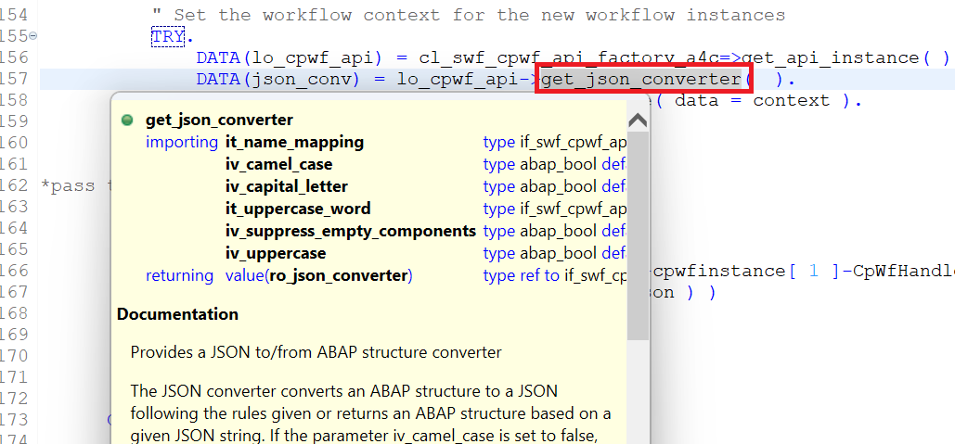

1. At last, you would call **setPayload** action of the BO interface I\_CPWF\_INST, Entity  CPWFInstance using **EML** Operation **MODIFY ENTITIES.** This wouldprovide the input data for the workflow instance in **JSON** format using input parameters **Workflow Handler ID** and **Context data in JSON format**.
2. Activate  the class.

### **Step4. Implement methods to handle callback in the Class Implementation Section.**

Implement the method  if\_swf\_cpwf\_callback~workflow\_instance\_completed to handle callback from SAP Build Process automation on workflow process completion.

**Insert** the following code snippet in the method and replace all occurrences of the placeholder #### with your **group ID.** You can use the **F1 help** to get detailed information on each EML statement.

**ABAP Code:**



Your method would look like this:

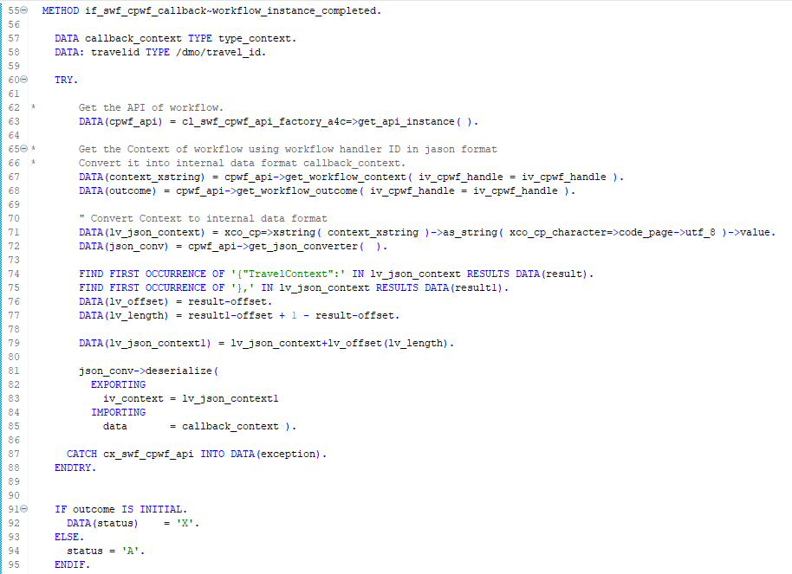

**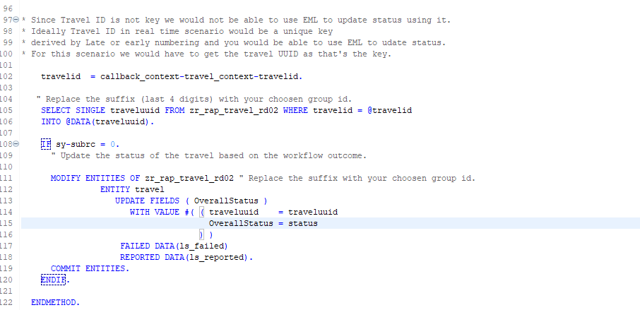**

**Short explanation of the flow logic:**

1. Class cl\_swf\_cpwf\_api\_factory\_a4c is used as a helper class to get access to the Workflow APIs.
2. With the **Workflow API Instance**  cpwf\_api  you would call method get\_workflow\_context  using **Workflow Handler Id** sent by SAP Build Process Automation during callback to get the **Context data in xstring format**.
3. Method call get\_workflow\_outcome  is used to get the outcome of Workflow sent by SBPA.
4. Next there is further logic to format the Context data received and deserialize it into internal data format.
5. **EML Operations** can be triggered with **key** values only, get the key for Business Object using root CDS View zr\_rap\_travel\_####.
6. Once we have the data, call the EML Operation MODIFY ENTITIES for Travel Business Object zr\_rap\_travel\_XXXX, entity travel to update the overall status of the travel instance as per the outcome of workflow sent by SAP Build Process Automation.
7. Activate  the class.

Your Implementation for the Workflow Class is now complete. In the further tutorial you will see how we can call the workflow trigger method from the RAP Business Object.

### **Step 5: Test Yourself.**

To mark a class as **Workflow Callback Class**, add \_\_\_\_\_\_\_\_\_\_\_\_\_ to the class definition.

* Interface **if\_swf\_cpwf\_callback**.
* RAP Façade call **I\_CPWF\_INST.**
* Both.

## **Group 3: Tutorial 2**

## **Extend the RAP Travel Application to integrate workflow capability.**

Intermediate 30mins

[BTP ABAP Environment, Tutorial, Intermediate, SBPA Workflows](https://developers.sap.com/tutorial-navigator.html?tag=tutorial%3Aexperience%2Fintermediate&tag=tutorial%3Atype%2Ftutorial&tag=programming-tool%3Aabap-exte)

Enhance the business object behaviour using determination to add workflow functionality.

You will learn.

* How to define determinations
* How to implement determination
* How to use EML in Local Mode

Owner: [Ruchi Dobriyal](https://github.com/RDobriyal)

Prerequisites:

* You need to have access to an SAP BTP, ABAP environment, or SAP S/4HANA Cloud, ABAP environment or SAP S/4HANA (release 2022 or higher) system.
* Latest Version of ADT with abapGit plugin.

<https://eclipse.abapgit.org/updatesite/>

* You have created all prerequisites and steps as part of Group 3, Tutorial 1.

As part of this tutorial, you would extend the Managed Business Object behaviour by defining and implementing a **Determination on Save** trigger\_travelworkflow during action **Create** (trigger condition). You will use the Entity Manipulation Language (**EML**) to implement the transactional behavior of the Travel business object. 

On **Creation** of the travel booking, during save event Determination on Save trigger\_travelworkflow will be called. trigger\_travelworkflow will intern **trigger workflow** for travel approval and set the overall status of the travel to **awaiting approval.**

*Reminder: Do not forget to replace the suffix placeholder #### with your chosen or assigned group ID in the exercise steps below.*

*A determination is an optional part of the business object behavior that modifies instances of business objects based on trigger conditions. Determinations are implemented when we need to calculate values of few fields based on trigger conditions.*

*A determination is implicitly invoked by the RAP framework if the trigger condition of the determination is fulfilled. Trigger conditions can be CRUD operations or fields. Determinations can be created* ***On modify*** *or* ***On save*** *based on if we want to display the value of a calculated field to the user before save or after save.*

*Please refrain from writing fields which needs to be determined / calculated in the trigger conditions of that determination* *as it might lead to infinite loop since we are specifying the calculated field in the trigger condition and changing the field inside that determination which is resulting in application dumps.*

### **Step1. Define Determination.**

**Extend** the Business Object Behaviour definition with **Determination** **On Save**.

1. Go to behaviour definition of the Travel root entity  ZR\_RAP\_TRAVEL\_#### and define the determination trigger\_travelworkflow. For that, insert the following code as shown in the screenshot below.

ABAP CODE:

**determination** trigger\_travelworkflow **on** **save** **{create;}**

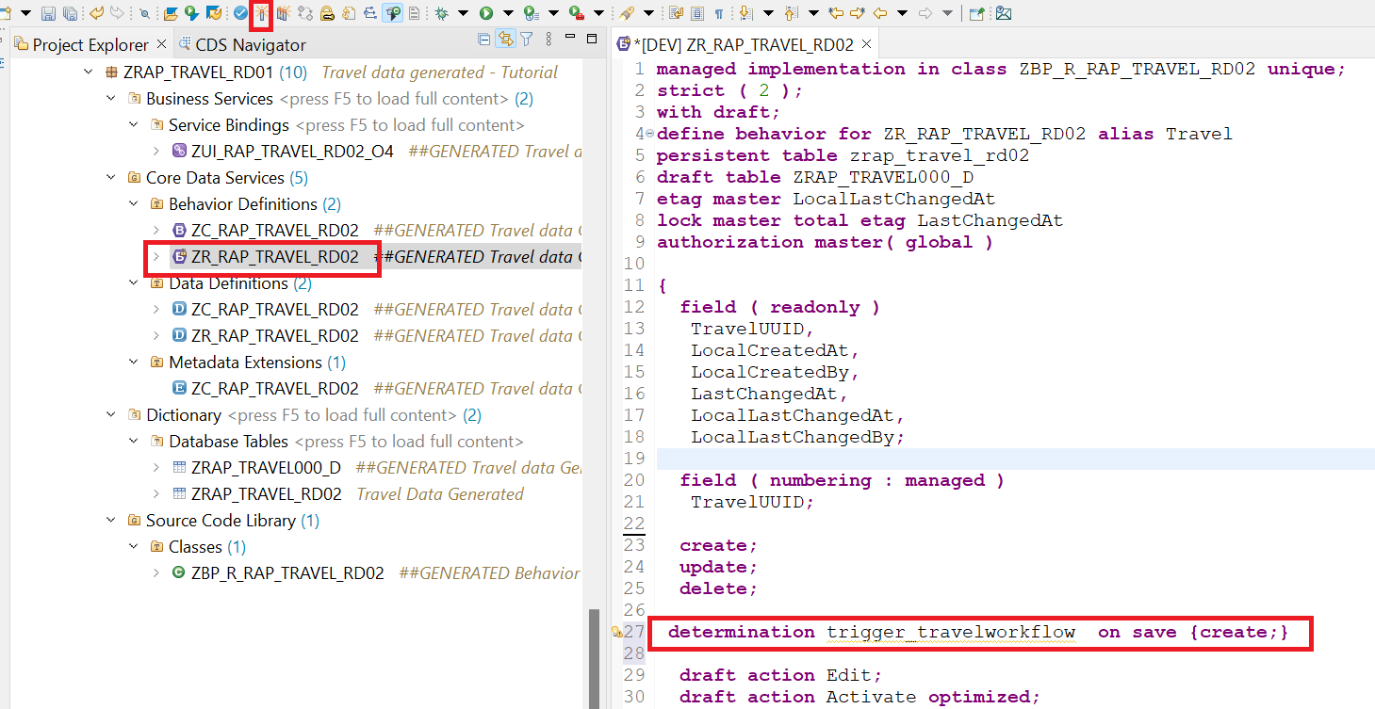

**Short explanation:** This statement specifies that the determination would be triggered during the save event of the operation Create. The determined values would be visible after save.

1. **Activate**  the changes.
2. **Click** on the **Quick Assist**  besides the newly added line of code and the **Add method for determination** to declare the required method in behavior implementation class.

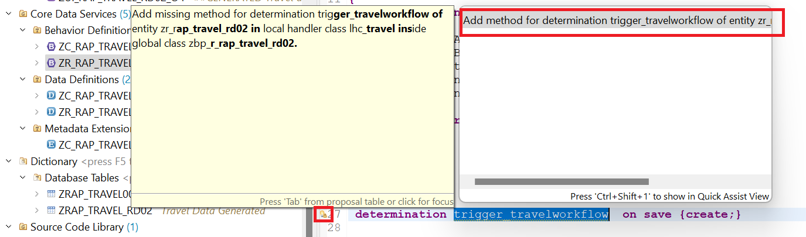

1. As a result, you can see the method **trigger\_travelworkflow** for determination is added in the **local handler class** **LHC\_TRAVEL** of Behaviour implementation class **ZBP\_R\_RAP\_TRAVEL\_RD02.**

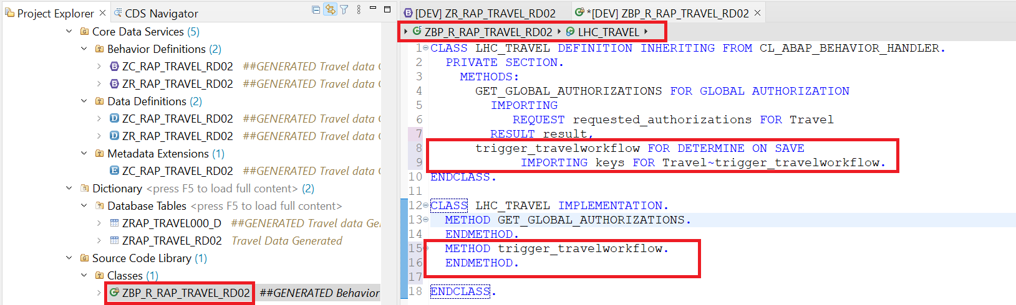

**Short explanation**:

* The addition **FOR DETERMINE** indicates that the method provides the implementation of a determination and the addition **ON SAVE** indicates the **specified trigger time** (during save event).
* **IMPORTING** parameter **keys** – is an internal table containing the **keys of the instances** the determination will be executed on. Includes all entities for which keys must be assigned.
* Implicit **CHANGING** parameter **reported** - used to return messages in case of failure.

1. Activate  the changes.

### **Step3. Implement Determination.**

You will now implement the determination to call trigger workflow method created as part of the previous tutorial and update the overall status of Travel to **(W)** Awaiting Approval using **(EML)** Entity Manipulation Language **In Local Mode.**

*Please note that calling EML statements in the local mode - by using the* [addition IN LOCAL MODE](https://help.sap.com/doc/abapdocu_cp_index_htm/CLOUD/en-US/index.htm)–*excludes feature controls and authorization checks. This addition can thus be used to change a BO Instance locally by the same RAP business object itself, i. e. not for other RAP business objects.*

* + 1. Define the **local constant** travel\_status to store the allowed value of the **overall status** of a **Travel** instance. Insert the following code snippet in the definition part of the local handler class lhc\_travel in **Private section** as shown on the screenshot below.

Insert the following code snippet.

ABAP Code:



Your code should look like:

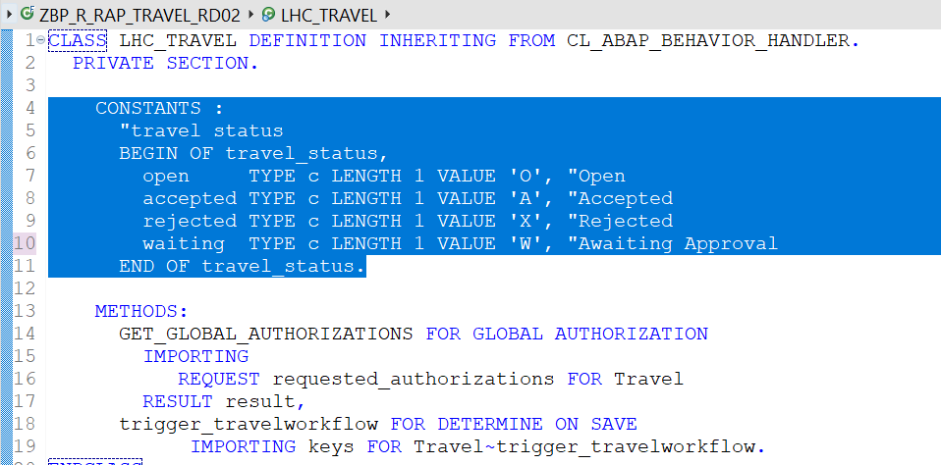

* + 1. Implement the method trigger\_travelworkflow in the local class lhc\_travel of the Business Object Behaviour Implementation Class ZBP\_R\_RAP\_TRAVEL\_####.

Insert the following code snippet in the method and replace all occurrences of the placeholder #### with your group ID. You can use the **F1 help** to get detailed information on each EML statement.

ABAP Code:



Your code should look like:

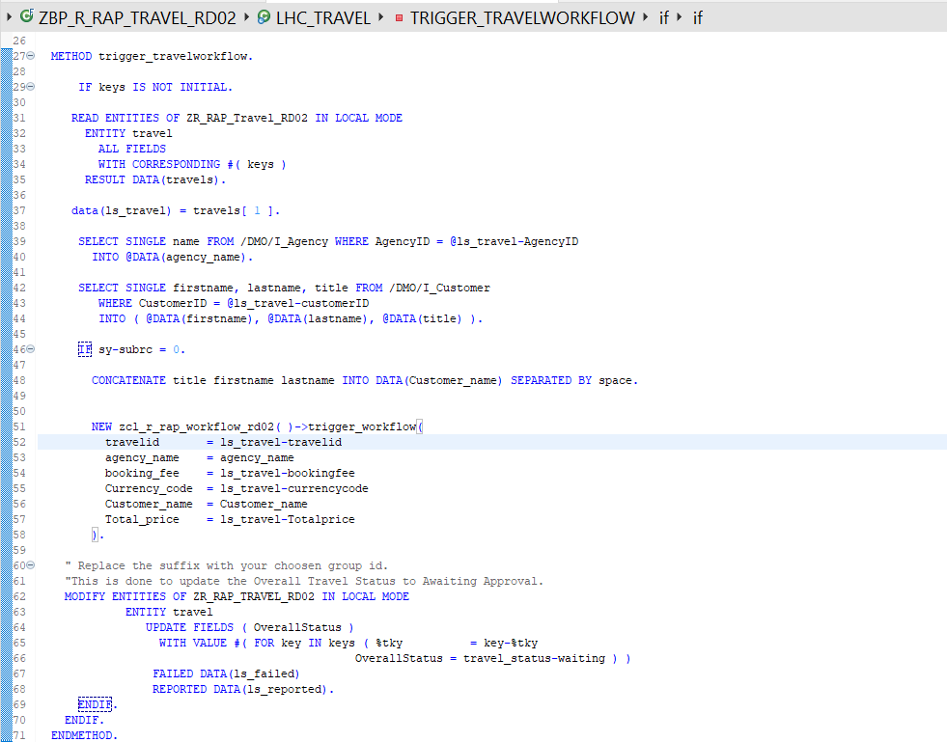

**Short explanation**:

* **Read** the travel instance(s) data with the transferred keys **(keys)** using the EML statement **READ ENTITIES IN Local MODE.**
* **Enrich** the data by getting Agency Name and Customer name, by reading from the CDS Views.
* **Call** the method trigger\_workflow from workflow handler class zcl\_r\_rap\_workflow\_#### to **trigger workflow** by passing all the required data retrieved in the previous steps.
* As a final step update the **Overall Travel Status** to ‘**Awaiting Approval**’ by EML statement MODIFY ENTITIES IN Local Mode using the transferred keys **(keys).**
  + 1. **Activate**  the changes.

***Where*** *to trigger the workflow from in case of* ***Unmanaged Numbering****?*

*The actions required to trigger a workflow instance are defined as save actions and can thus only be called during the* ***early or late save phase*** *of a RAP BO.*

*Choosing between early or late phase totally depends on how you are generating the numbering for the key field like in this case* ***Travel ID.*** *As the key would be required for your identifying the entry during callback processing.*

***Early Numbering:*** *Trigger the workflow instance in a determination on save with the required methods.*

***Late Numbering:*** *Trigger the workflow in a determination on save. To get the generated key field , you can set the payload with the setPayload method even later in the adjust\_numbers method.*

### **Step4. Add Value Help to enrich Travel Application** **UI.**

Without proper values for Customer ID and Agency ID the read on the CDS views to get Customer Name and Agency Name would not work. Thus, add value help to the fields to select values.

1. Go to metadata extension for your RAP Application.

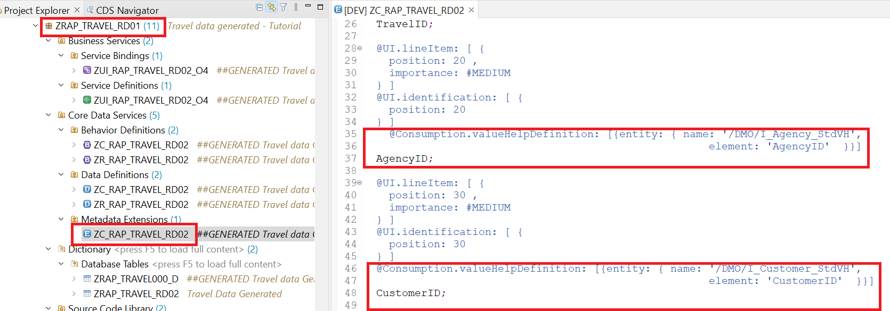

1. Using the below **annotation** add **value help** for **Agency ID.**

Insert this code above the field name AgencyID in Metadata Extension.

ABAP Code**:**

@Consumption.valueHelpDefinition:

[{entity: { name: ' /DMO/I\_Agency\_StdVH',

element: ' AgencyID' }}]

1. Using the below **annotation** add **value help** for **Customer ID.**

Insert this code above the field name CustomerID in Metadata Extension.

ABAP Code**:**

@Consumption.valueHelpDefinition:

[{entity: { name: '/DMO/I\_Customer\_StdVH',

element: 'CustomerID' }}]

**Short explanation:** Here entity name is the Value help CDS View for field and element name in the corresponding field name in Value Help CDS View for which the Value help is being provisioned.

**Value Help** should now be **available** for the fields.

With this you are done with the implementation part, further we will see how to **Preview**, **run,** **monitor,** and **troubleshoot** the **Travel App**.

***Please Note that in case your value help shows no data try to clear your browser cache or try previewing the application with browser in Inprivate or Incognito mode.***

### **Step 5: Test Yourself.**

To initialize values of few fields and display on the UI before save, determination should be trigged.

* On Save.
* On Modify.

# Group 4

## **Run, Monitor, and Troubleshoot**

1Tutorials 15mins [BTP ABAP Environment, Tutorial, Intermediate, SBPA Workflows](https://developers.sap.com/tutorial-navigator.html?tag=tutorial%3Aexperience%2Fintermediate&tag=tutorial%3Atype%2Ftutorial&tag=programming-tool%3Aabap-exte)

Run the Process to experience end-to-end flow and utilize various tools in BTP ABAP environment and SAP Build Process Automation for monitoring and troubleshooting.

### **Tutorials**

* Run the end-to-end business process workflow, Monitoring and troubleshoot.

## **Group 4: Tutorial 1**

## **Run end to end Business Process Workflow, Monitor and Troubleshoot**

Beginner 10mins [BTP ABAP Environment, Tutorial, Intermediate, SBPA Workflows](https://developers.sap.com/tutorial-navigator.html?tag=tutorial%3Aexperience%2Fintermediate&tag=tutorial%3Atype%2Ftutorial&tag=programming-tool%3Aabap-exte)

Run end to end business process starting for previewing RAP Travel Application, creating a Travel, Checking the Inbox in SBPA for triggered workflow process, Actioning the Approval form. Also check for Travel Overall Status Update during workflow trigger and call back.

You will learn:

* How to run the process.
* Monitor and trouble shoot in BTP ABAP Environment.
* How to access integrated Inbox in SAP Build Process Automation to work on the task.
* Monitor and troubleshoot in SBPA.

Owner: [Ruchi Dobriyal](https://github.com/RDobriyal)

Prerequisites:

* You have bought a licensed version of SAP BTP ABAP Environment
* [SAP BTP tenant with SAP Build Process Automation](https://developers.sap.com/tutorials/spa-subscribe-booster.html) subscription and Instance.

<https://developers.sap.com/tutorials/spa-subscribe-booster.html>

### **Step 1: Run the travel Application to Create Travel.**

Run the Travel Application to trigger workflow.

1. Goto **Service Binding** of your application > Choose **Entity** > **Preview**.

Open Preview in **Browser** with **InPrivate or Incognito mode**.

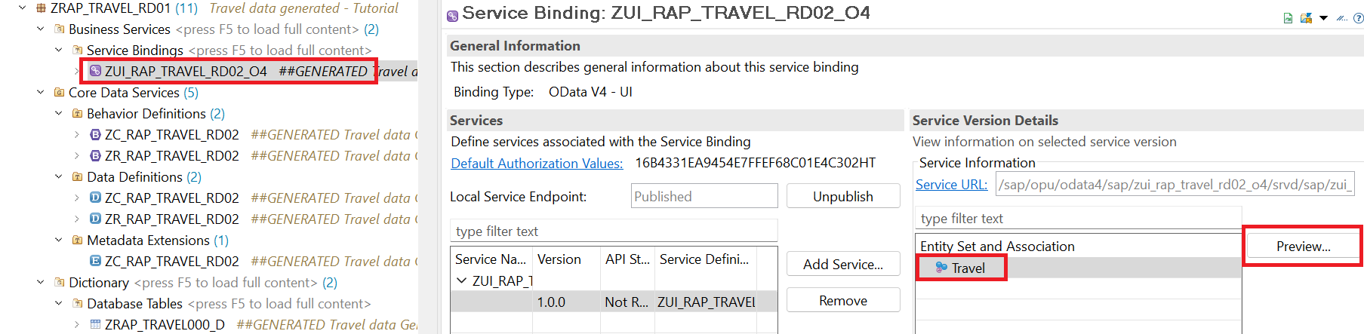

1. The service will appear in a **Fiori Elements preview**.

The table does not yet contain any data to preview.

**Choose Create** to create new Travel entries.

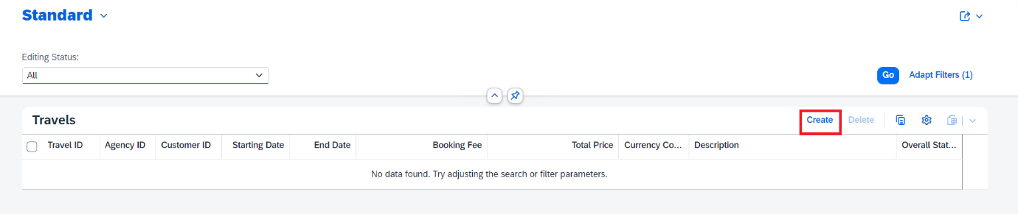

1. **Enter** **Values** and choose **Create**.

As currently there is no validation in place enter any values.

At least enter the below fields to the see complete functionality.

| **Field Name** | **Value** |
| --- | --- |
| Travel ID | Enter **any number e.g., ‘1234’**. Ideally you would implement early or late numbering. |
| Customer ID | Select from the **F4 help** |
| Agency ID | Select from the **F4 help** |
| Booking Fee | Enter any Fee e.g., **20.00** |
| Currency Code | Enter any value e.g., **EUR** |
| Total Price | Enter any Price e.g., **500.00** |

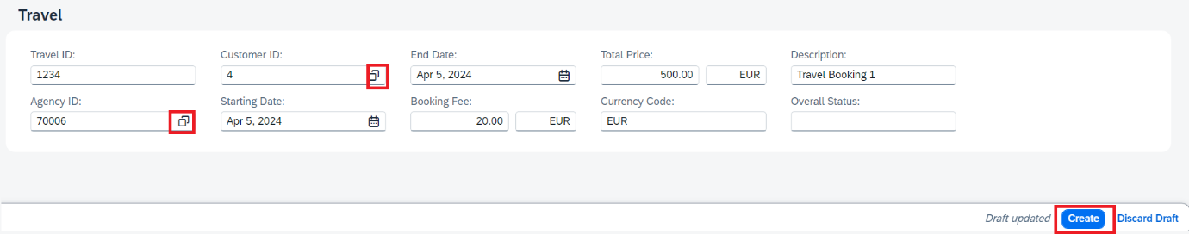

Please note that the **workflow is triggered** in SAP Build Process Automation as you clicked on **Create.**

1. Travel is now created.

Please note that the **status of the Travel** is set to **W** (Awaiting Approval).

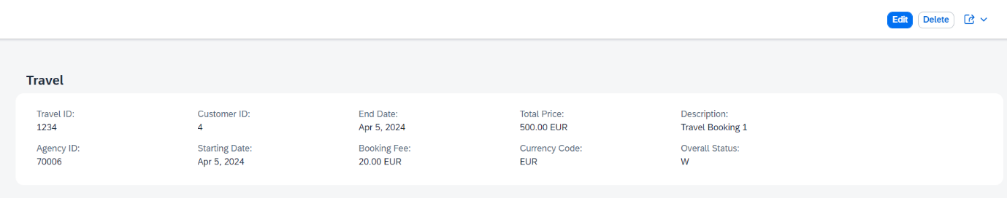

### **Step 2: Go to SAP Build Process Automation to Action the workflow.**

1. Form the SAP Build Process Automation **Lobby,** choose **My Inbox** to access the **Approval Form**.

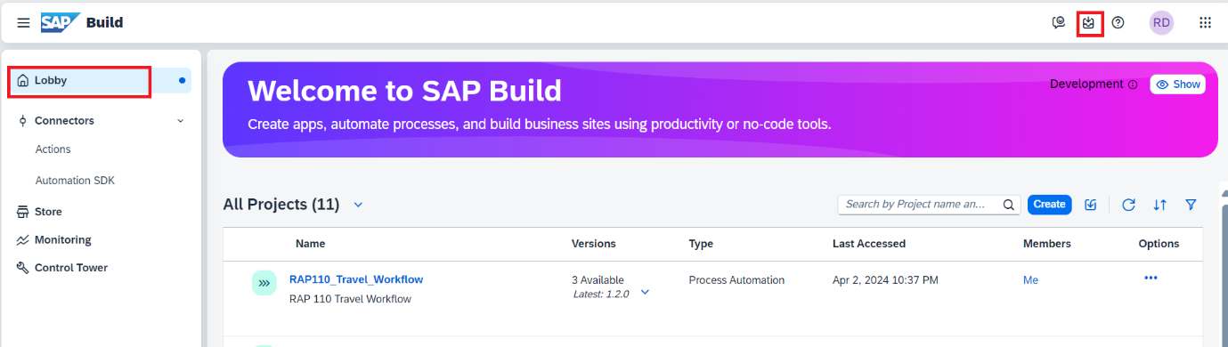

1. Here you can see the **Workflow Task** created**.**

Please note the **Description** of the **Task. I**t is coming from the **Approval form you Created.**

1. **Choose** the **Task** for Travel ID that you created e.g., ‘**1234’.**

This will display the Approval Form with the Travel Details.

1. Enter **Approved** in **Comments**.
2. Choose Approved.

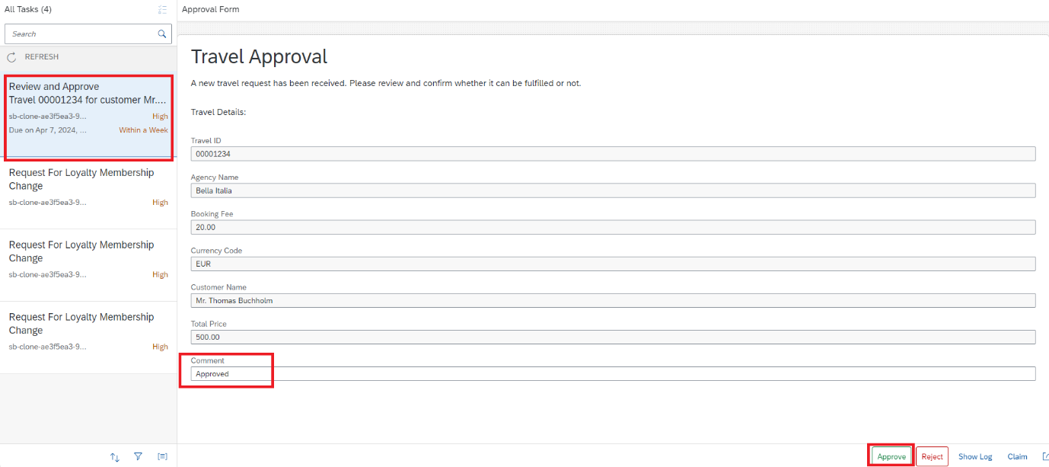

Your Travel Task is now Approved.

### **Step 3: Go back to the Travel Application Preview.**

Refresh the page to see the updates. Overall Travel should now be set to **Approved** (A).

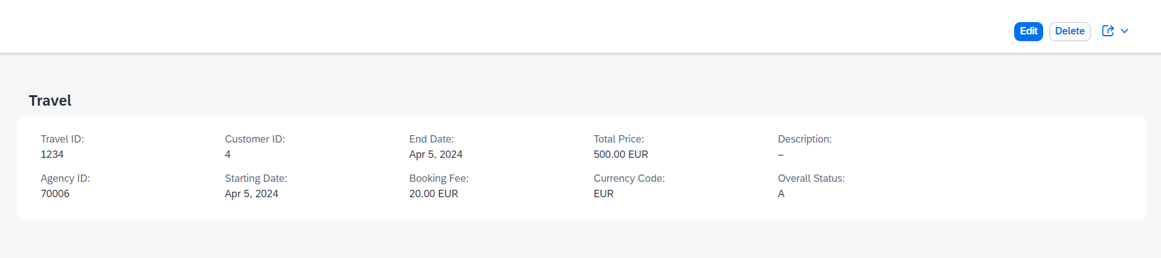

### **Step 4: Monitor and troubleshoot in BTP ABAP Environment.**

The **Application Interface Framework** (AIF) Monitoring tools enable you to monitor and troubleshoot communication between BTP ABAP Environment and SAP Build Process Automation.

1. **Enable** your **User** for monitoring. (Administrator **User required for this enablement)**.

* Click on the **BTP ABAP environment instance** in your BTP sub account to navigate to the Fiori launchpad using **Administrator User**



* Go to Maintain Business Roles App. Choose **New**> Enter **Name** & **Description** > Choose **Create**.

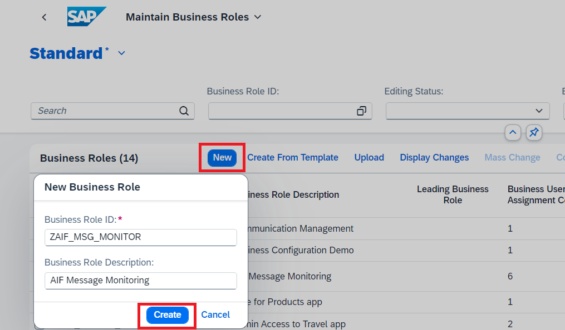

* Navigate to **Business Catalogs** > Choose **Add**.

Add the below 3 Communication Management Business Catalogs.

* [SAP\_CA\_BC\_COM\_CONF\_PC](https://3711fcf6-8003-4c20-80cb-e6a320ea05b7.abap-web.canaryaws.hanavlab.ondemand.com/ui)
* [SAP\_CA\_BC\_COM\_ERR\_PC](https://3711fcf6-8003-4c20-80cb-e6a320ea05b7.abap-web.canaryaws.hanavlab.ondemand.com/ui)
* [SAP\_CA\_BC\_COM\_OP\_ERR\_PC](https://3711fcf6-8003-4c20-80cb-e6a320ea05b7.abap-web.canaryaws.hanavlab.ondemand.com/ui)

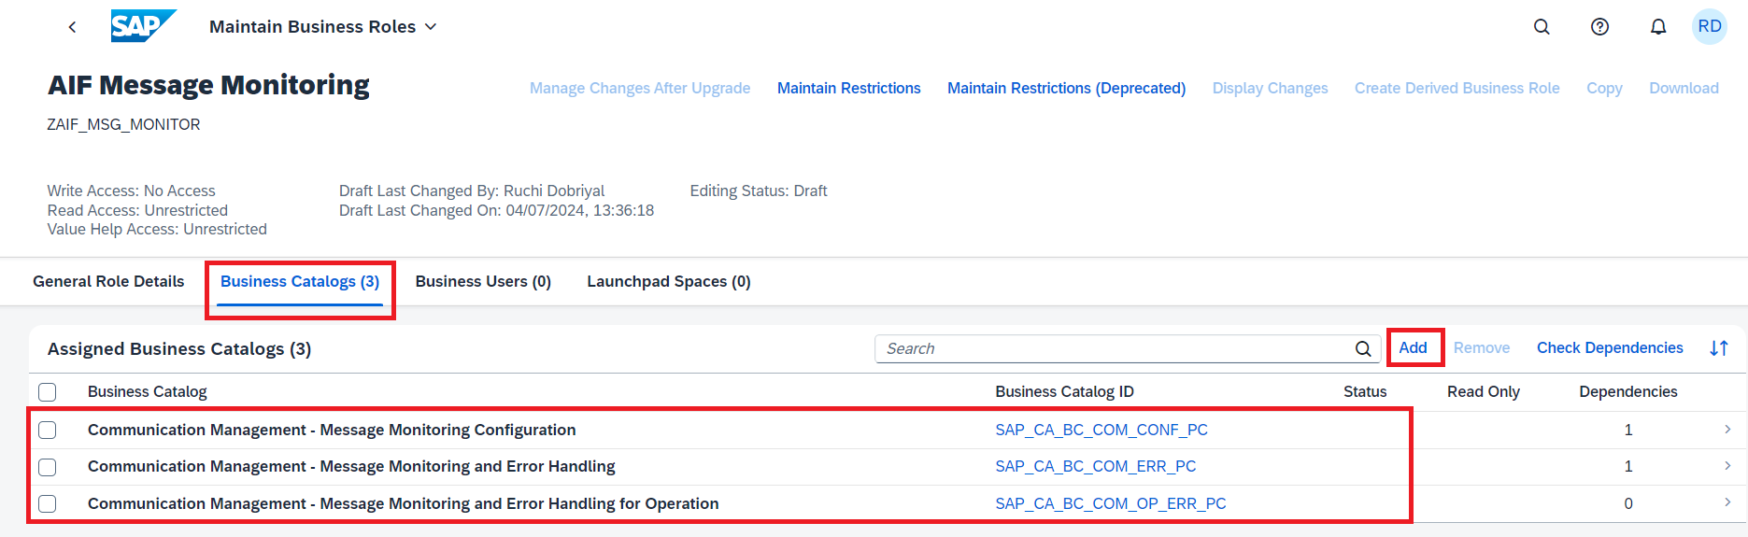

* Navigate to Users > Choose Add to select add your User > Choose Save.

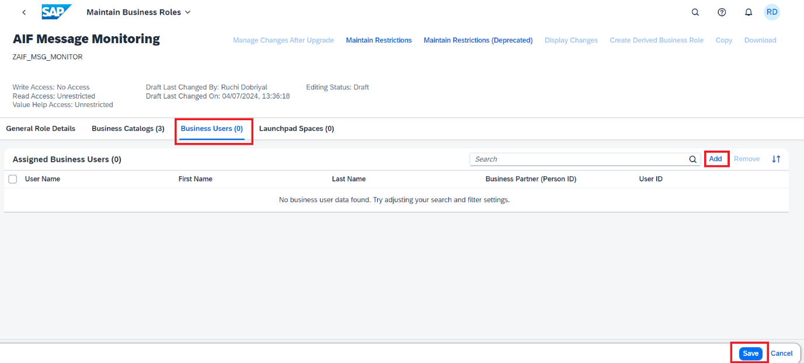

1. Go to **Assign Recipients to User** App > Choose your **User** > Select **Assign**.

Assign Recipients (Processes) to your User. This is to make sure that the user can monitor only the processes assigned.

Depending upon user’s roles and responsibilities, Recipients (processes) can be assigned.

For monitoring workflow communication with SAP Build Process Automation **Assign** the below **Recipients**:

| **Namespace** | **Recipient** |
| --- | --- |
| /SWFCP (for workflow capability) | REC\_PROC\_BGRFC (process bgRFC)  REC\_RAISE\_EVT (Recipient for raise of event) |

Repeat the process and **Assign** each recipient:

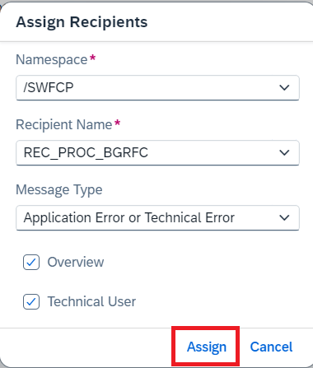

Your User is now **Enabled** for Workflow Communication **Monitoring** with SAP Build Process Automation via. AIF Communication Management Applications.

1. Open **Message Monitoring Overview** app or Message **Dashboard** app to monitor processes and check messages in case of failures/errors for troubleshooting.

Navigate Message Monitoring Overview > Choose /SWFCP – PROC\_BGRFC – 1 > Choose the process you triggered > Check the message log and other details.

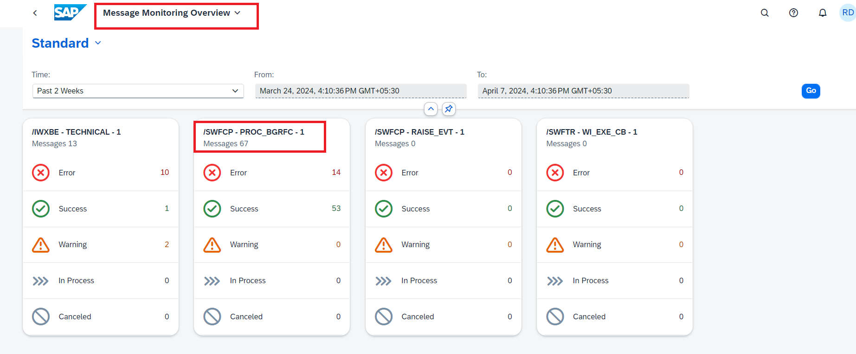

**Select > on** the line item to display further details.

Below error usually comes when the **interface fields do not match.**

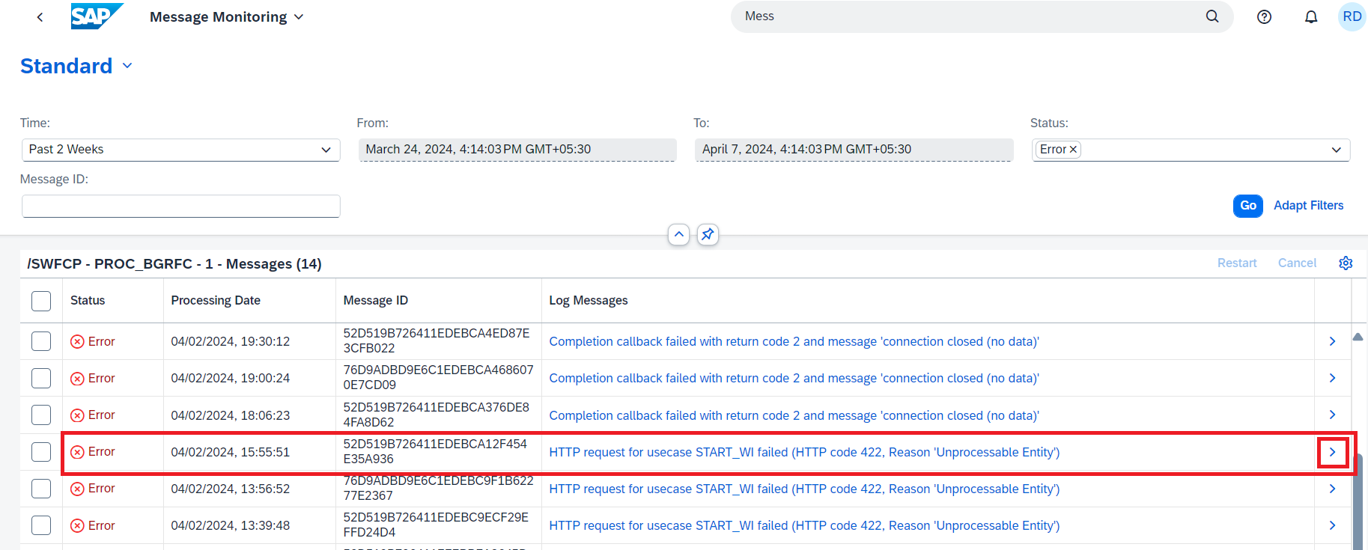

1. Debugging your code.

In case you are not able to figure out why the call is failing using the monitoring tools you might want to troubleshoot by debugging the code. Note the below users you are debugging.

| **Process** | **Debugger User** |
| --- | --- |
| Workflow Trigger (**Outgoing Call**) | **User Performing the action** ‘Create Travel’ |
| Process Completion Notification Method if\_swf\_cpwf\_callback~workflow\_instance\_completed (**Inbound call**) | Activate the breakpoint for **SAP\_WFRT** user |

In case the call is successful in BTP ABAP Environment, but you still do not see your approval form, or you do not see a status update to (A) in BTP ABAP Environment post actioning the Approval form you would have to check if the process on the SBPA side is successful or not. The same have been explained in the next step.

### **Step 5: Monitor and troubleshoot in SAP Build Process Automation.**

You have monitoring tools available on the SBPA side which show detailed log for each step in your Business Process as no debugging is possible here.

* Navigate to the **Monitor** tab and choose **Process and Workflow Instances**.

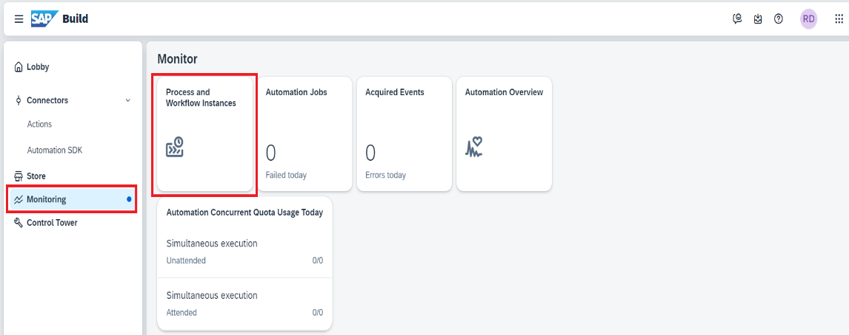

* Choose ALL **status** > Choose your **Project >** Choose the workflow instance and click **>.**

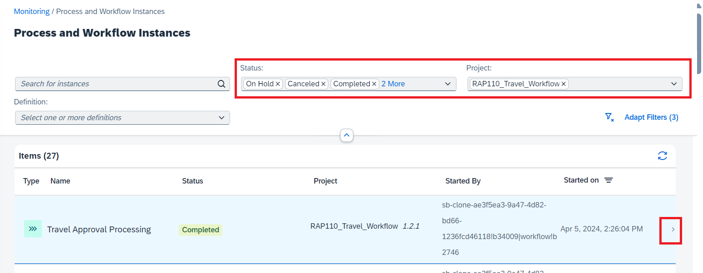

* Choose **Logs** to see the messages at each step.

Choose **Context** to see the data transformation at each step and finally the outgoing context during the callback to BTP ABAP environment.

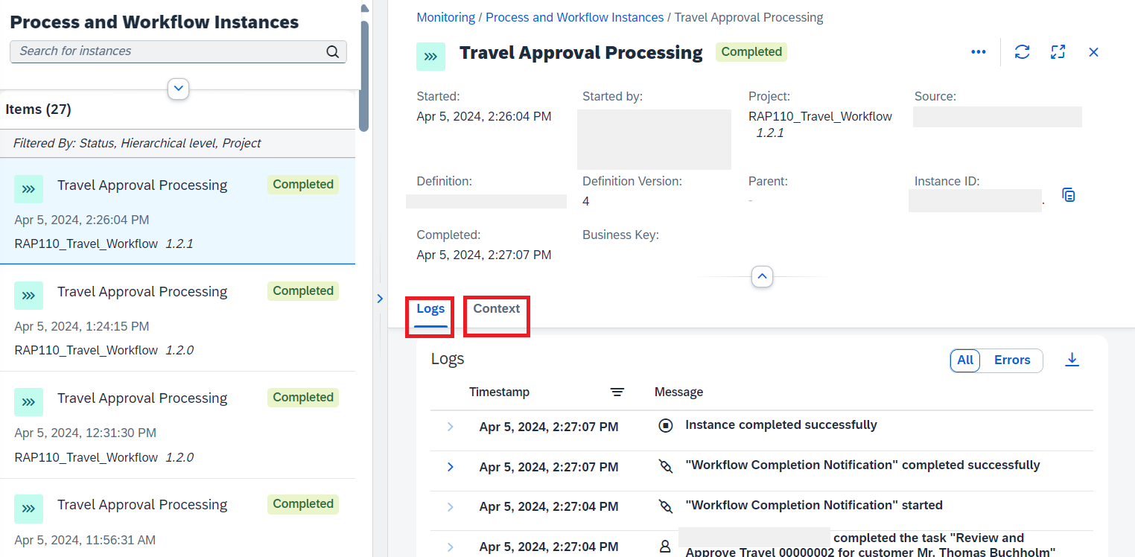

### **Step 6: Test Yourself.**

Choose the Message Monitoring tools available in BTP ABAP Environment.

* Message Monitoring Overview.
* Message Dashboard.
* Both